

FACULTY OF COMPUTING AND INFORMATION TECHNOLOGY

BACS3183 ADVANCED DATABASE MANAGEMENT

Assignment

Semester 202501

Programme (Year, Sem & Group) | : | RDS2 S2 G3
Date Submitted | : | 22/04/2025

Team members:
No | Name (Block Letters - Alphabetical Order) | Student ID | Marks
1 | LEE XUE YI | 2314717
2 | LIM YEE SYUEN | 2314727
3 | LIM WEI KANG | 2314725
4 | NGOI WAN XUAN | 2314740
5 | WONG PENG SEUNG | 2314782

Declaration

We confirm that we have read and shall comply with all the terms and conditions of TAR UMT’s plagiarism policy.

We declare that this assignment is free from all forms of plagiarism and for all intents and purposes is my own properly derived work.
 |  |  |  | 
Name:  LEE XUE YI | Name:  LIM YEE SYUEN | Name:  LIM WEI KANG | Name:  NGOI WAN XUAN | Name:  WONG PENG SEUNG
  Signature: |   Signature: | 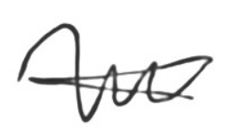  Signature: |   Signature: |   Signature:
Date: 22/04/2025 | Date: 22/04/2025 | Date: 22/04/2025 | Date: 22/04/2025 | Date: 22/04/2025

Assignment Assessment Form
No | Member Name (Alphabetical order) | Programme (Year-Semester-Group)
1. | LEE XUE YI | RDS2-S2-G3
2. | LIM YEE SYUEN | RDS2-S2-G3
3. | LIM WEI KANG | RDS2-S2-G3
4. | NGOI WAN XUAN | RDS2-S2-G3
5. | WONG PENG SEUNG | RDS2-S2-G3

Task  No. |  |  | Task Descriptions | Weightage | Criteria | 1 | 2 | 3 | 4 | 5 | Comment
1  (CLO 1) |  |  | Entity Relationship Diagram | 10% | - A complete ER data model in 3rd Normal Form.  - All primary keys, foreign keys, relationships and attributes must be clearly shown.  - Standalone system design will be given lower marks compare to online system design.
2  (CLO 1) |  |  | Data Definition (DDL) | 10% | - Relevant integrity constraints to ensure database integrity must be included.  - Necessary check constraints and default values to enforce business rules should also be included.
3  (CLO 1) |  |  | Data records | 5% | - Sufficient quality data records must be created for each table.
4  (CLO 3) |  |  | Queries | 5% | - Each team member is to design and produce two quality and useful queries for decision making at any two different management levels: strategic, tactical or operational.  - Single table queries are not allowed.  - Multiple table queries with aggregate functions (where appropriate) must be used.  - View(s) is/are ought to be incorporated, where necessary.  - These 2 queries cannot be used directly for report body.
 |  |  |  | 5%
5  (CLO 2) |  |  | Stored Procedures | 5% | - Each team member is to design and create two stored procedures that cater for the use case scenarios for the system.  - Quality, usefulness and importance of the stored procedures must be considered.
 |  |  |  | 5%
6  (CLO 2) |  |  | Triggers | 5% | - Each team member is to design and create two triggers that enforces system-wide business rules and policies.  - Quality, usefulness and functionality of the triggers must be considered.
 |  |  |  | 5%
7  (CLO 3) |  |  | Reports | 10% | - Each team member is to create two procedures to generate two reports (summary, detail and on demand basis reports) for the company.  - Parameter value(s) should be passed to the procedure, where necessary.  - Cursor must be used in report generation (prefer nested cursors or multiple cursors).  - Usefulness, complexity and presentation of the reports must be considered.
 |  |  |  | 10%
8  (CLO 2) |  |  | Extra Effort | 10% | - Sequences, indexes, views, output formatting, exceptions and/or functions, must be incorporated where necessary.  - Usefulness and application of each of the above to enhance the efficiency and effectiveness of the information system must be considered.  - Linking of all the tasks of every team member in creating a quality information system must be considered.
9  (CLO 3) |  |  | Presentation & Participation | 15% | - Run the single script file from Task 2 – 3 to create the new system database on the lab server.  - Individual presentation on Task 4 – 8.  - Q & A  - Actively participate in class discussion.
Assignment Marks / 100
*CLO 1: Develop the relational database system with the appropriate integrity constraints and security control. (P3, PLO3)
*CLO 2: Design the solutions to issues pertaining to database efficiency and effectiveness using appropriate techniques. (C4, PLO2)
*CLO 3: Extract information from the database using efficient SQL query construct. (C4, PLO6)
Table of Content
Chapter 1 Background of the System 8
1.1 Type of system (Standalone System) 8
1.2 List of Modules 8
1.2.1 Membership Management 8
1.2.2 Book Borrowing & Returning 9
1.2.3 Book Reservation 9
1.2.4 Loan Extension 9
1.2.5 Overdue & Fine Management 9
1.2.6 Book Management 10
1.2.7 Advanced Book Search 10
1.2.8 Invoice Management 10
1.2.9 Blacklist Management 10
1.2.10 Reporting Module 10
Chapter 2 Entity-Relationship Modeling 11
2.1 Business Rules 11
2.1.1 Membership 11
2.1.2 Borrowing and Returning Process 11
2.1.3 Book Reservation 11
2.1.4 Track Due Dates and Overdue Books 11
2.1.5 Fines 12
2.1.6 Extend the Book Loan Period 12
2.1.7 Enable Advanced Search Options for Books 12
2.1.8 Invoice Generation 12
2.2 Assumptions 12
2.3 ERD 13
Chapter 3 Data Definition 14
3.1 CREATE TABLE Statements 14
3.1.1 Member Table 14
3.1.2 Book Table 14
3.1.3 BookTittle Table 14
3.1.4 Librarian Table 14
3.1.5 BookReservation Table 15
3.1.6 BorrowingRecord Table 15
3.1.7 Billing Table 15
3.1.8 Invoice Table 16
3.1.9 MaintenanceRequest Table 16
3.1.10 Technician Table 16
3.1.11 Library Resource Table 16
3.1.12 FacilityReservation Table 17
3.2 Sample Records 17
3.2.1 Member 17
3.2.2 Book 18
3.2.3 BookTittle 18
3.2.4 Librarian 19
3.2.5 BookReservation 20
3.2.6 BorrowingRecord 20
3.2.7 Billing 21
3.2.8 Invoice 21
3.2.9 MaintenanceRequest 22
3.2.10 Technician 23
3.2.11 Library Resource 23
3.2.12 FacilityReservation 24
Chapter 4 Queries, Procedures, Triggers and Reports 25
4.1 LEE XUE YI 25
4.1.1 Query 1 : Borrowing Records Managed by Librarian 25
4.1.2 Query 2 : Highest Reserved Books Report 26
4.1.3 Procedure 1: Membership Renewal Procedure 27
4.1.4 Procedure 2 : Generate Invoice for Billing 28
4.1.5 Trigger 1 : Limit Loan Extension 29
4.1.6 Trigger 2: Prevent Borrowing for Invalid Members 29
4.1.7 Report 1: Technician Maintenance Requests Report 30
4.1.8 Report 2 : Members with Overdue Books and Active Reservations Report 31
4.2 LIM YEE SYUEN 33
4.2.1 Query 1 : Technician Maintenance History Report 33
4.2.1 Query 2 : Borrowed Books by Category Report 34
4.2.3 Procedure 1 : Return Book and Handle Late Fees 35
4.2.4 Procedure 2 : Reserve Book for Member 36
4.2.5 Trigger 1 : Update Book Status and Reservation on Return 37
4.2.6 Trigger 2 : Blacklist Members for Late Returns 38
4.2.7 Report 1 : Most Active Members Report 38
4.2.8 Report 2 : Detail Report of Facility Reservations by Member 39
4.3 LIM WEI KANG 41
4.3.1 Query 1: Books Borrowed by Members 41
4.3.2 Query 2 : Members Using Resource 43
4.3.3 Procedure 1: Borrowing Control and Record Insertion 44
4.3.4 Procedure 2: Validated Facility Reservation Entry 45
4.3.5 Trigger 1 : Validate Book Reservation Fulfillment 47
4.3.6 Trigger 2: Auto-Mark Top Borrowed Books as Popular 48
4.3.7 Report 1 : Top Borrowing Members by Category 48
4.3.8 Report 2 : Summary Report - Total Overdue Amounts by Member Type 50
4.4 NGOI WAN XUAN 51
4.4.1 Query 1 : Top 5 Most Borrowed Books 51
4.4.2 Query 2 : Top 5 Most Frequently Reserved Facilities 52
4.4.3 Procedure 1 : Borrowing Due Date Extension 54
4.4.4 Procedure 2 : Cancel Facility Reservation with Validation 54
4.4.5 Trigger 1: Auto-Close Facility on Reservation 55
4.4.6 Trigger 2: Block Facility Reservations by Ineligible Members 55
4.4.7 Report 1 : Book Reservations Status (Fulfilled and Unfulfilled) 56
4.4.8 Report 2 : Summary Report of Active Members by Type 57
4.5 WONG PENG SEUNG 58
4.5.1 Query 1 : Payment Details 58
4.5.2 Query 2 : Yearly Billing Report 59
4.5.3 Procedure 1 : Member Registration and Billing Setup 60
4.5.4 Procedure 2 : Technician-Based Maintenance Request Creation 61
4.5.5 Trigger 1 : Block Borrowing by Inactive Members 63
4.5.6 Trigger 2 : Restrict Re-Reservation Within 14 Days 63
4.5.7 Report 1 : Active Member Borrowed Books 63
4.5.8 Report 2: Billing Details by Member ID with Title, Footer, and Total Amount 65
Chapter 5 Extra Effort Highlights 67
5.1 (LEE XUE YI) 67
5.1.1 Sequence 67
5.1.2 Exception 1 67
5.1.3 Exception 2 68
5.1.4 Output Formatting for Query 1 68
5.1.5 Output Formatting for Query 2 69
5.1.6 Indexes 1 70
5.1.7 Indexes 2 70
5.2 (LIM YEE SYUEN) 71
5.2.1 Sequence 71
5.2.2 Exception 1 71
5.2.3 Exceptions 2 72
5.2.4 Output Formatting for Query 1 72
5.2.5 Output Formatting for Query 2 74
5.1.6 Indexes 1 75
5.1.7 Indexes 2 75
5.3 (LIM WEI KANG) 75
5.3.1 Sequence 1 75
5.3.2 Sequence 2 76
5.3.3 Exceptions 1 76
5.3.4 Exceptions 2 77
5.3.5 Output Formatting for Query 1 78
5.3.6 Output Formatting for Query 2 78
5.3.7 Indexes 1 79
5.3.8 Indexes 2 79
5.4 (NGOI WAN XUAN) 80
5.4.1 Sequence 80
5.4.2 Exceptions 1 80
5.4.3 Exceptions 2 81
5.4.4 Output Formatting for Query 1 81
5.4.5 Output Formatting for Query 2 82
5.4.6 Indexes 1 82
5.4.7 Indexes 2 83
5.5 (WONG PENG SEUNG) 83
5.5.1 Sequence 83
5.5.2 Exceptions 1 84
5.5.3 Exceptions 2 84
5.5.4 Output Formatting for Query 1 85
5.5.5 Output Formatting for Query 2 85
5.5.6 Indexes 1 86
5.5.7 Indexes 2 87

Chapter 1 Background of the System

1.1 Type of system (Standalone System)
The Library Management System (LMS) will be developed as a standalone system, meaning it will operate locally within the library premises, without the need for an internet connection. This system will be deployed on a dedicated local server or machines within the library environment. It will provide functionality such as membership registration, book borrowing, reservations, tracking due dates, and fine management directly on-site. The system will be accessed by library staff and registered members, ensuring that all actions, such as borrowing books, extending loan periods, paying fines, or making reservations, are processed locally, without relying on external connectivity.
In this configuration, the system will strictly follow the business rules set out for membership management, borrowing processes, and fine tracking. For instance, members must provide valid personal details to register, and only those with active membership will be allowed to borrow books, reserve books, or extend borrowing periods. Premium members will have additional privileges, such as the ability to reserve VIP rooms, while both Standard and Premium members are subject to fines for overdue books. Importantly, the system ensures that expired memberships can no longer reserve books or extend loan periods but still allows members to return books and settle fines.
Given that the LMS will operate without internet access, it is fully contained within the library’s infrastructure. This reduces the risk of external security breaches, as no external network access is required. It also ensures that library staff can manage the system and all transactions locally without the need for ongoing internet connectivity. Additionally, even if the network is down or unavailable, the library can continue operating without disruption, as the system does not depend on any external servers or services.
Furthermore, by using a standalone system, the library can retain full control over its data and operations, ensuring that membership details, borrowed items, and financial records remain secure and localized. While only members with active status can borrow books or reserve items, all actions and updates (such as due dates, fines, and book reservations) will be tracked and updated in real-time within the system. The ability to manage the system in this isolated environment also simplifies maintenance, as all updates and backups can be done internally without reliance on external vendors or services.
In conclusion, the standalone system model is the most suitable choice for the LMS as it aligns with the library’s operational needs for security, local access, and control over its resources. This approach ensures that the system is tailored to meet the business rules and assumptions, providing an efficient and secure way to manage library operations while maintaining complete control over all user interactions and data processing.

1.2 List of Modules
The following modules represent the core functional components of the Library Management System. Each module is designed to handle specific processes based on the defined business rules, ensuring smooth library operations, efficient resource management, and a seamless user experience for both members and administrators.

1.2.1 Membership Management
The Membership Management module is responsible for handling the registration, renewal, and tracking of library members. It collects valid personal information such as name and contact details, and assigns a unique, non-transferable Member ID upon successful registration. This module supports two tiers: Standard and Premium. Standard members are charged RM 10 while Premium members are charged RM 20. Membership is valid for one year and can be renewed (RM 5 for Standard, RM 10 for Premium). The system also tracks membership status to enforce access to specific features — for instance, only Premium members can reserve VIP rooms, and only active members can borrow or reserve books. This module ensures expired members can still return books and pay fines, but are restricted from new reservations or loan extensions.

1.2.2 Book Borrowing & Returning
This module manages the full lifecycle of borrowing and returning books. It enforces tier-based borrowing limits — up to 2 books for Standard members and 5 for Premium members — and prevents new loans if the member has reached their limit or has outstanding fines. Borrowing periods are also tier-dependent: one month for Standard members and two months for Premium. When a book is borrowed, the system records the due date; upon return, the status is updated to “AVAILABLE.” This module ensures borrowing rules are followed, and all due dates are tracked systematically for later validation by other modules such as fine calculation and overdue handling.

1.2.3 Book Reservation
The Book Reservation module enables active members to reserve books in advance, ensuring fair access through a first-come, first-served policy. It supports a maximum of three reservations per member, though only one book can be reserved per reservation ID. Reservation statuses progress through "PLACED," "READY," and "FULFILLED" depending on the book’s availability and pickup status. If a book is not picked up within 14 days, the reservation is automatically cancelled. The module blocks reservations by members who have overdue books or unpaid fines and ensures that only active members are eligible to reserve books. This module plays a critical role in improving book circulation efficiency and member satisfaction.

1.2.4 Loan Extension
The Loan Extension module allows members to request an extension of their book loan period before the due date. Each loan is eligible for only one extension, and the extension period is fixed at 7 days. Once granted, the new due date is recorded in the system, and the member's borrowing history is updated accordingly. Expired members or those trying to extend after the due date are automatically denied. This module is integrated with the borrowing and overdue management modules to ensure compliance with the rules and prevent abuse of the extension feature.

1.2.5 Overdue & Fine Management
This module monitors all borrowed books and automatically flags items as “OVERDUE” if they are not returned by the due date. It calculates late fees at RM 1 per day, including weekends and holidays, and prohibits partial payments. After 30 days of non-return or non-payment, members are automatically blacklisted. The module prevents blacklisted members from borrowing or reserving new books but still allows them to return items and settle fines. It ensures timely returns, enforces accountability, and protects the library's inventory from prolonged misuse.

1.2.6 Book Management
The Book Management module maintains detailed records of all books in the library. This includes metadata such as title, author, genre, publication year, and availability status. It tracks borrowing frequency and marks books as “POPULAR” if they are frequently borrowed. Only books marked as “AVAILABLE” can be borrowed or reserved. This module interacts with other core systems (borrowing, returning, reservation) to ensure book status is always up to date. It supports inventory control and enhances the member experience by surfacing high-demand books during searches.

1.2.7 Advanced Book Search
This module enhances the user experience by providing comprehensive search functionality. Members can filter books using various criteria such as title, author, genre, publication year, and popularity. The system highlights “POPULAR” books in search results to help users quickly identify trending titles. It allows for efficient exploration of the library's resources, supporting both targeted and discovery-based browsing.

1.2.8 Invoice Management
The Invoice Management module automatically generates invoices for all fines that have been paid. Each invoice includes payment method, billing ID, amount, and date. The module maintains records for all financial transactions related to fine payments, ensuring traceability and accountability. It works in tandem with the Fine and Overdue module to ensure that every payment is properly documented and retrievable for audit or reporting purposes.

1.2.9 Blacklist Management
This module tracks members with overdue items or unpaid fines and automatically blacklists them if issues remain unresolved after 30 days. Blacklisted members are blocked from borrowing and reserving but can still return books and make payments. This mechanism enforces compliance with library rules while still allowing recovery from the blacklist through corrective action. It maintains the integrity of library resources and minimizes abuse.

1.2.10 Reporting Module
The Reporting Module generates both operational and analytical reports for library staff. Reports include data such as top borrowed books, book reservation statuses (fulfilled/unfulfilled), summary of active members by type, billing details by member, and overdue amounts by member category. These reports help librarians monitor usage trends, identify bottlenecks, and make data-driven decisions for improving library operations and policies.

Chapter 2 Entity-Relationship Modeling

2.1 Business Rules

2.1.1 Membership
- A user must provide valid personal details (e.g., name and contact) to register as a library member.
- There are 2 tiers of membership,which are Standard membership and Premium membership.
- Every member will receive a unique Membership ID upon successful registration.
- Standard membership and Premium membership can make reservations and extend borrowing periods. Only Premium membership can make reservations for VIP rooms.
- Each member will be charged RM 10 per registration for Standard membership and RM 20 for Premium membership
- Every membership is valid for 1 year from the registration date.
- The extended borrowing period remains valid even if membership expires, as long as the person was a member before.
- Expired memberships must be renewed RM 5 for Standard membership and RM 10 for Premium membership.

2.1.2 Borrowing and Returning Process
- A Standard member can have up to maximum only 2 book loans.
- A Premium member can have up to maximum only 5 book loans.
- Standard member borrowing period for each book is 1 month.
- Premium Member borrowing period for each book is 2 months.
- A borrower must return their previously borrowed book before borrowing another.
- Members with unpaid fines cannot borrow new books.
- Books must be returned by the due date to avoid late fees.
- Once returned, the book status changes to "AVAILABLE".

2.1.3 Book Reservation
- Only member with active membership can reserve books
- A member can have a maximum of 3 reservations, but only one book can be reserved at a time.
- Reserved books are held for 14 days for members to borrow.
- If the member does not borrow the book within this period, the reservation is auto-cancelled.
- Members with overdue books or unpaid fines cannot make new reservations.
- Reservations are processed on a first come first served basis.
- When a reservation is made, the status is updated to "PLACED".
- If the book is returned, the status changes to "READY".
- Once picked up, the reservation status is updated to "FULFILLED".

2.1.4 Track Due Dates and Overdue Books
- Each borrowed book has a due date recorded in the system.
- If a book is not returned by the due date, it is marked as "OVERDUE".
- Borrowers are blacklisted after 30 days if the book is not returned.

2.1.5 Fines
- A late fee of RM 1 per day per book is charged for overdue books. ：
- Fines increase daily, including weekends and holidays.
- No partial payments are not allowed.
- Unpaid fines after 30 days will result in the borrower being blacklisted.

2.1.6 Extend the Book Loan Period
- Only members can request a loan extension before the due date.
- Members can extend the book loan due date only for 7 days.
- A book loan can be extended only once.
- Once extended, the new due date is updated in the system.

2.1.7 Enable Advanced Search Options for Books
- Members can search for books by title, author, genre, publication year, and popularity.
- Books marked as "POPULAR" (frequently borrowed) are highlighted in search results.

2.1.8 Invoice Generation
- Each paid fine generates a specific invoice.

2.2 Assumptions
- Only members with active membership status can apply for book reservation and book loan.
- MemberID are unique and non-transferable.
- Membership status expired after the expiration date.
- One reservation only can last for 3 days, otherwise the reservation will be cancelled automatically.
- System enforcing members can only have up to maximum 5 active book loans, non-member can only have up to maximum 3 active book loans.
- Only the available books can be borrowed by members and non-members.
- Only active members can reserve books.
- One reservationID can reserve only one book.
- System enforcing members can have a maximum of 3 reservations only.
- Fine will be charged an increase of RM 1 per day for overdue books.
- Expired members cannot reserve books or extend loan periods but can still return books and pay fines.
- Books must be returned in good condition, damaged or lost books incur replacement fees.
- Fines must be paid in full.
- Book loan extensions must be requested before the due date.
- The system automatically generates a fine invoice when a book is overdue.

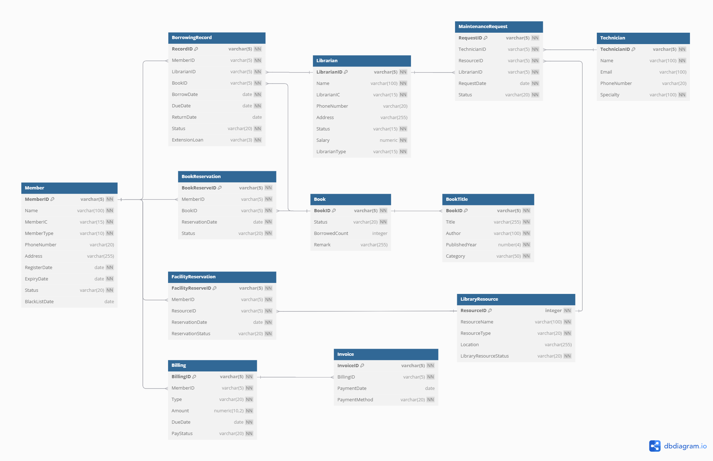
2.3 ERD
https://dbdiagram.io/d/67dbe2e275d75cc844ce6ca0

Chapter 3 Data Definition

3.1 CREATE TABLE Statements

3.1.1 Member Table
CREATE TABLE Member (
MemberID VARCHAR2(5) NOT NULL PRIMARY KEY,
Name VARCHAR2(100) NOT NULL,
MemberIC VARCHAR2(15) NOT NULL,
MemberType VARCHAR2(10) NOT NULL CHECK (MemberType IN ('Standard','Premium')),
PhoneNumber VARCHAR2(20) ,
Address VARCHAR2(255),
RegisterDate DATE NOT NULL,
ExpiryDate DATE NOT NULL,
Status VARCHAR2(20) NOT NULL CHECK (Status IN ('Active', 'Expired','Blacklisted')),
BlackListDate DATE
);

3.1.2 Book Table
CREATE TABLE Book (
BookID VARCHAR2(5) NOT NULL PRIMARY KEY,
Status VARCHAR2(20) NOT NULL CHECK (Status IN ('Available', 'Reserved')),
BorrowedCount NUMBER,
Remark VARCHAR2(255)
);

3.1.3 BookTittle Table
CREATE TABLE BookTitle (
BookID VARCHAR2(5) NOT NULL PRIMARY KEY,
Title VARCHAR2(255) NOT NULL,
Author VARCHAR2(100) NOT NULL,
PublishedYear NUMBER (4) NOT NULL,
Category VARCHAR2(50) NOT NULL CHECK (Category IN ('Fiction', 'Comic', 'Mystery','Science','Fantasy')),
FOREIGN KEY (BookID) REFERENCES Book(BookID)
);

3.1.4 Librarian Table
CREATE TABLE Librarian (
LibrarianID VARCHAR2(5) NOT NULL PRIMARY KEY,
Name VARCHAR2(100) NOT NULL,
LibrarianIC VARCHAR2(15) NOT NULL,
PhoneNumber VARCHAR2(20),
Address VARCHAR2(255),
Status VARCHAR(15) NOT NULL CHECK (Status IN ('Duty','Leave')),
Salary NUMBER NOT NULL,
LibrarianType VARCHAR2(15) NOT NULL CHECK (LibrarianType IN ('FullTime','PartTime'))
);

3.1.5 BookReservation Table
CREATE TABLE BookReservation (
BookReserveID VARCHAR2(5) NOT NULL PRIMARY KEY,
MemberID VARCHAR2(5) NOT NULL,
BookID VARCHAR2(5) NOT NULL,
ReservationDate DATE DEFAULT SYSDATE NOT NULL,
Status VARCHAR2(20) NOT NULL CHECK (Status IN ('Placed', 'Ready', 'Fulfilled','Cancelled')),
FOREIGN KEY (MemberID) REFERENCES Member(MemberID),
FOREIGN KEY (BookID) REFERENCES Book(BookID)
);

3.1.6 BorrowingRecord Table
CREATE TABLE BorrowingRecord (
RecordID VARCHAR2(5) NOT NULL PRIMARY KEY,
MemberID VARCHAR2(5) NOT NULL,
LibrarianID VARCHAR2(5) NOT NULL,
BookID VARCHAR2(5) NOT NULL,
BorrowDate DATE NOT NULL,
DueDate DATE NOT NULL,
ReturnDate DATE,
Status VARCHAR2(20) NOT NULL CHECK (Status IN ('Borrowed', 'Returned', 'Overdue')),
ExtensionLoan VARCHAR2(3) NOT NULL CHECK (ExtensionLoan IN ('Yes', 'No')),
FOREIGN KEY (MemberID) REFERENCES Member(MemberID),

3.1.7 Billing Table
CREATE TABLE Billing (
BillingID VARCHAR2(5) NOT NULL PRIMARY KEY,
MemberID VARCHAR2(5) NOT NULL,
Type VARCHAR2(20) NOT NULL CHECK (Type IN ('overdue' , 'RenewMember', 'RegisterMember')),
Amount NUMBER(10,2) NOT NULL,
DueDate DATE NOT NULL,
PayStatus VARCHAR2(20) NOT NULL CHECK (PayStatus IN ('Paid', 'Unpaid',’Overdue’)),
FOREIGN KEY (MemberID) REFERENCES Member(MemberID)
);

3.1.8 Invoice Table
CREATE TABLE Invoice (
InvoiceID VARCHAR2(5) NOT NULL PRIMARY KEY,
PaymentDate DATE,
PaymentMethod VARCHAR2(20) NOT NULL CHECK (PaymentMethod IN ('Cash' , 'Online Banking', 'e-wallet')),
BillingID VARCHAR2(5) NOT NULL,
FOREIGN KEY (BillingID) REFERENCES Billing(BillingID)
);

3.1.9 MaintenanceRequest Table
CREATE TABLE MaintenanceRequest (
RequestID VARCHAR2(5) NOT NULL PRIMARY KEY,
TechnicianID VARCHAR2(5) NOT NULL,
ResourceID VARCHAR2(5) NOT NULL,
LibrarianID VARCHAR2(5) NOT NULL,
RequestDate DATE NOT NULL,
Status VARCHAR2(20) NOT NULL CHECK (Status IN ('Pending', 'In Progress', 'Completed')),
FOREIGN KEY (TechnicianID) REFERENCES Technician(TechnicianID),
FOREIGN KEY (ResourceID) REFERENCES LibraryResource(ResourceID),
FOREIGN KEY (LibrarianID) REFERENCES Librarian(LibrarianID)
);

3.1.10 Technician Table
CREATE TABLE Technician (
TechnicianID VARCHAR2(5) NOT NULL PRIMARY KEY,
Name VARCHAR2(100) NOT NULL,
Email VARCHAR2(100) UNIQUE,
PhoneNumber VARCHAR2(20),
Specialty VARCHAR2(30) NOT NULL CHECK (Specialty IN ('Equipment Repair','Facilities Administration'))
);

3.1.11 Library Resource Table
CREATE TABLE LibraryResource (
ResourceID VARCHAR2(5) NOT NULL PRIMARY KEY,
ResourceName VARCHAR2(100) NOT NULL UNIQUE,
ResourceType VARCHAR2(20) NOT NULL CHECK (ResourceType IN ('Facility', 'Equipment')),
Location VARCHAR2(255), -- Only applicable for facilities
LibraryResourceStatus VARCHAR2(20) NOT NULL CHECK (LibraryResourceStatus IN ('Available', 'Under Maintenance', 'Closed'))
);

3.1.12 FacilityReservation Table
CREATE TABLE FacilityReservation (
FacilityReserveID VARCHAR2(5) NOT NULL PRIMARY KEY,
MemberID VARCHAR2(5) NOT NULL,
ResourceID VARCHAR2(5) NOT NULL,
ReservationDate DATE DEFAULT SYSDATE NOT NULL,
ReservationStatus VARCHAR2(20) NOT NULL CHECK (ReservationStatus IN ('Ready','Cancelled')),
FOREIGN KEY (MemberID) REFERENCES Member(MemberID),
FOREIGN KEY (ResourceID) REFERENCES LibraryResource(ResourceID)
);

3.2 Sample Records

3.2.1 Member
INSERT INTO Member VALUES ('M001', 'John Tan', '990101145321', 'Standard', '60123456789', '12, Jalan Setia 3, Taman Setia, 40100 Shah Alam, Selangor', '2024-11-01', '2025-11-01', 'Active', NULL);
INSERT INTO Member VALUES ('M002', 'Alicia Wong', '880505085432', 'Premium', '60175567890', '45, Lorong Mawar 2, Taman Mawar, 11600 Jelutong, Pulau Pinang', '2023-05-10', '2024-05-10', 'Expired', NULL);
INSERT INTO Member VALUES ('M003', 'Mohd Faiz', '950203105678', 'Standard', '60132233445', '18, Jalan Harmoni, Taman Desa, 81200 Johor Bahru, Johor', '2024-08-20', '2025-08-20', 'Active', NULL);
INSERT INTO Member VALUES ('M004', 'Siti Aminah', '920716086543', 'Premium', '60169876543', '3A, Jalan Ria 5, Taman Ria, 08000 Sungai Petani, Kedah', '2023-07-15', '2024-07-15', 'Blacklisted', '2024-07-01');
INSERT INTO Member VALUES ('M005', 'Kevin Lim', '910430075432', 'Standard', '60147654321', '67, Jalan Merdeka, Kampung Baru, 50300 Kuala Lumpur', '2021-03-30', '2022-03-30', 'Expired', NULL);
INSERT INTO Member VALUES ('M006', 'Nurul Huda', '001010086789', 'Premium', '60183334567', '9, Jalan Bukit, Taman Bukit Indah, 68000 Ampang, Selangor', '2023-10-10', '2024-10-10', 'Active', NULL);
INSERT INTO Member VALUES ('M007', 'Adam Lee', '970205115432', 'Standard', '60198765432', '28, Jalan Melur, Taman Melur, 75200 Melaka', '2024-12-05', '2025-12-05', 'Active', NULL);
INSERT INTO Member VALUES ('M008', 'Tan Mei Ling', '890115045678', 'Premium', '60123334455', '112, Jalan Tun Razak, 50400 Kuala Lumpur', '2023-01-15', '2024-01-15', 'Blacklisted', '2024-01-01');
INSERT INTO Member VALUES ('M009', 'Amirul Hakim', '851110025432', 'Standard', '60171122334', '10, Jalan Kempas, Taman Kempas, 70400 Seremban, Negeri Sembilan', '2024-11-10', '2025-11-10', 'Expired', NULL);
INSERT INTO Member VALUES ('M010', 'Chong Wei', '900410096543', 'Premium', '60135566778', '99, Jalan Pelangi, Taman Pelangi, 43000 Kajang, Selangor', '2023-04-10', '2024-04-10', 'Expired', NULL);

3.2.2 Book
INSERT INTO Book VALUES ('B001', 'Reserved', 10, 'Popular');
INSERT INTO Book VALUES ('B002', 'Reserved', 10, 'Popular');
INSERT INTO Book VALUES ('B003', 'Available', 3, NULL);
INSERT INTO Book VALUES ('B004', 'Available', 2, NULL);
INSERT INTO Book VALUES ('B005', 'Reserved', 1, NULL);
INSERT INTO Book VALUES ('B006', 'Available', 4, NULL);
INSERT INTO Book VALUES ('B007', 'Reserved', 2, NULL);
INSERT INTO Book VALUES ('B008', 'Reserved', 20, 'Popular');
INSERT INTO Book VALUES ('B009', 'Reserved', 2, NULL);
INSERT INTO Book VALUES ('B010', 'Reserved', 3, NULL);

3.2.3 BookTittle
INSERT INTO BookTitle VALUES ('B001', 'The Lost Kingdom', 'Ahmad Faizal', 2012, 'Fantasy');
INSERT INTO BookTitle VALUES ('B002', 'Space Explorers', 'Lim Wei Seng', 2011, 'Science');
INSERT INTO BookTitle VALUES ('B003', 'Mystery at Genting', 'Nurul Aina', 2011, 'Mystery');
INSERT INTO BookTitle VALUES ('B004', 'Legends of Langkawi', 'Zulkifli Hasan', 2014, 'Fiction');
INSERT INTO BookTitle VALUES ('B005', 'The Time Machine', 'Tan Mei Ling', 1999, 'Science');
INSERT INTO BookTitle VALUES ('B006', 'Kampung Heroes', 'Amirul Rahman', 1998, 'Comic');
INSERT INTO BookTitle VALUES ('B007', 'Dragon Scrolls', 'Liew Chun Wah', 1999, 'Fantasy');
INSERT INTO BookTitle VALUES ('B008', 'Detective from KL', 'Azimah Noor', 2000, 'Mystery');
INSERT INTO BookTitle VALUES ('B009', 'Solar Invasion', 'Wong Kee Mun', 2013, 'Science');
INSERT INTO BookTitle VALUES ('B010', 'The Jungle Book', 'Rahman Idris', 2012, 'Fiction');

3.2.4 Librarian
INSERT INTO Librarian VALUES ('L001', 'Ahmad Faiz', '860101100123', '60123456789', 'Jalan Tunku, Kuala Lumpur, 50450', 'Duty', 3500, 'FullTime');
INSERT INTO Librarian VALUES ('L002', 'Siti Nurhaliza', '750908012345', '60123456780', 'No. 45, Jalan Sejahtera, Petaling Jaya, 46300', 'Leave', 2000, 'PartTime');
INSERT INTO Librarian VALUES ('L003', 'Muhammad Ali', '840202110234', '60123456781', 'Jalan Malinja, Shah Alam, 40000', 'Duty', 4000, 'FullTime');
INSERT INTO Librarian VALUES ('L004', 'Lim Wei Ting', '950305210456', '60123456782', 'No. 21, Jalan Timur, Georgetown, 10200', 'Duty', 2100, 'PartTime');
INSERT INTO Librarian VALUES ('L005', 'Fazlina Aziz', '870607120567', '60123456783', 'No. 10, Jalan Sri Petaling, Kuala Lumpur, 57100', 'Leave', 3300, 'FullTime');
INSERT INTO Librarian VALUES ('L006', 'Tan Chia Ling', '930811110678', '60123456784', 'No. 33, Jalan Pantai, Johor Bahru, 80000', 'Duty', 3600, 'FullTime');
INSERT INTO Librarian VALUES ('L007', 'Kumar A/L Rajoo', '800423013789', '60123456785', 'No. 88, Jalan Bukit, Malacca, 75000', 'Leave', 3400, 'PartTime');
INSERT INTO Librarian VALUES ('L008', 'Lee Mei Li', '900520023890', '60123456786', 'No. 55, Jalan Kuning, Ipoh, 31400', 'Duty', 3200, 'FullTime');
INSERT INTO Librarian VALUES ('L009', 'Jamilah Hasan', '860507103901', '60123456787', 'No. 17, Jalan Maju, Batu Pahat, 83000', 'Leave', 1900, 'PartTime');
INSERT INTO Librarian VALUES ('L010', 'Ahmad Zaki', '920701140012', '60123456788', 'No. 100, Jalan Kemuning, Kuching, 93100', 'Duty', 3700, 'FullTime');

3.2.5 BookReservation
INSERT INTO BookReservation VALUES ('RE001', 'M020', 'B008', '2017-04-20', 'Fulfilled');
INSERT INTO BookReservation VALUES ('RE002', 'M021', 'B008', '2017-07-15', 'Fulfilled');
INSERT INTO BookReservation VALUES ('RE003', 'M022', 'B008', '2017-12-10', 'Fulfilled');
INSERT INTO BookReservation VALUES ('RE004', 'M001', 'B021', '2017-08-05', 'Cancelled');
INSERT INTO BookReservation VALUES ('RE005', 'M006', 'B001', '2017-10-15', 'Fulfilled');
INSERT INTO BookReservation VALUES ('RE006', 'M023', 'B008', '2018-01-25', 'Cancelled');
INSERT INTO BookReservation VALUES ('RE007', 'M008', 'B098', '2018-02-04', 'Fulfilled');
INSERT INTO BookReservation VALUES ('RE008', 'M013', 'B006', '2018-02-15', 'Fulfilled');
INSERT INTO BookReservation VALUES ('RE009', 'M004', 'B055', '2018-02-18', 'Fulfilled');
INSERT INTO BookReservation VALUES ('RE010', 'M014', 'B006', '2018-03-13', 'Fulfilled');

3.2.6 BorrowingRecord
INSERT INTO BorrowingRecord VALUES
('BR001', 'M001', 'L002', 'B001', '2017-08-05', '2017-09-05', '2017-09-06', 'Overdue', 'No');
INSERT INTO BorrowingRecord VALUES
('BR002', 'M006', 'L004', 'B001', '2017-10-15', '2017-12-15', '2017-12-01', 'Returned', 'No');
INSERT INTO BorrowingRecord VALUES
('BR003', 'M013', 'L001', 'B001', '2018-10-01', '2018-11-01', '2018-10-29', 'Returned', 'No');
INSERT INTO BorrowingRecord VALUES
('BR004', 'M012', 'L003', 'B001', '2018-12-20', '2019-02-20', '2019-02-19', 'Returned', 'Yes');
INSERT INTO BorrowingRecord VALUES
('BR005', 'M025', 'L006', 'B001', '2019-04-15', '2019-05-15', '2019-05-25', 'Overdue', 'Yes');
INSERT INTO BorrowingRecord VALUES
('BR006', 'M030', 'L002', 'B001', '2019-09-01', '2019-11-01', '2019-10-30', 'Returned', 'No');
INSERT INTO BorrowingRecord VALUES
('BR007', 'M010', 'L004', 'B001', '2020-03-01', '2020-05-01', '2020-05-02', 'Overdue', 'No');
INSERT INTO BorrowingRecord VALUES
('BR008', 'M007', 'L005', 'B001', '2021-12-10', '2022-01-10', '2021-12-15', 'Returned', 'No');
INSERT INTO BorrowingRecord VALUES
('BR009', 'M022', 'L006', 'B001', '2023-01-01', '2023-03-01', '2023-01-02', 'Returned', 'No');
INSERT INTO BorrowingRecord VALUES
('BR010', 'M028', 'L007', 'B001', '2024-06-07', '2024-08-07', NULL, 'Borrowed', 'Yes');

3.2.7 Billing
INSERT INTO Billing VALUES ('BL001', 'M001', 'overdue', 1, '2017-10-06', 'Paid');
INSERT INTO Billing VALUES ('BL002', 'M023', 'overdue', 11, '2018-04-07', 'Paid');
INSERT INTO Billing VALUES ('BL003', 'M008', 'overdue', 10, '2018-05-18', 'Overdue');
INSERT INTO Billing VALUES ('BL004', 'M010', 'overdue', 10, '2018-07-01', 'Paid');
INSERT INTO Billing VALUES ('BL005', 'M006', 'overdue', 9, '2019-01-10', 'Paid');
INSERT INTO Billing VALUES ('BL006', 'M017', 'overdue', 3, '2019-04-20', 'Paid');
INSERT INTO Billing VALUES ('BL007', 'M014', 'overdue', 4, '2019-05-17', 'Overdue');
INSERT INTO Billing VALUES ('BL008', 'M017', 'overdue', 3, '2019-05-17', 'Paid');
INSERT INTO Billing VALUES ('BL009', 'M003', 'overdue', 1, '2019-06-20', 'Paid');
INSERT INTO Billing VALUES ('BL010', 'M025', 'overdue', 10, '2019-06-24', 'Paid');

3.2.8 Invoice
INSERT INTO Invoice VALUES ('IV001', '2017-10-01', 'Cash', 'BL001');
INSERT INTO Invoice VALUES ('IV002', '2018-04-06', 'Online Banking', 'BL002');
INSERT INTO Invoice VALUES ('IV003', '2018-07-01', 'e-wallet', 'BL004');
INSERT INTO Invoice VALUES ('IV004', '2019-01-08', 'Cash', 'BL005');
INSERT INTO Invoice VALUES ('IV005', '2019-04-16', 'Online Banking', 'BL006');
INSERT INTO Invoice VALUES ('IV006', '2019-05-11', 'Cash', 'BL008');
INSERT INTO Invoice VALUES ('IV007', '2019-06-15', 'e-wallet', 'BL009');
INSERT INTO Invoice VALUES ('IV008', '2019-06-24', 'Cash', 'BL010');
INSERT INTO Invoice VALUES ('IV009', '2019-07-06', 'Online Banking', 'BL011');
INSERT INTO Invoice VALUES ('IV010', '2019-07-21', 'Cash', 'BL012');

3.2.9 MaintenanceRequest
INSERT INTO MaintenanceRequest VALUES
('MR001', 'T001', 'R003', 'L001', '2023-01-02', 'Pending');
INSERT INTO MaintenanceRequest VALUES
('MR002', 'T003', 'R005', 'L002', '2023-01-03', 'In Progress');
INSERT INTO MaintenanceRequest VALUES
('MR003', 'T007', 'R008', 'L003', '2023-01-03', 'Completed');
INSERT INTO MaintenanceRequest VALUES
('MR004', 'T009', 'R015', 'L004', '2023-01-04', 'Pending');
INSERT INTO MaintenanceRequest VALUES
('MR005', 'T013', 'R019', 'L005', '2023-01-06', 'In Progress');
INSERT INTO MaintenanceRequest VALUES
('MR006', 'T002', 'R002', 'L006', '2023-01-07', 'Completed');
INSERT INTO MaintenanceRequest VALUES
('MR007', 'T004', 'R004', 'L007', '2023-01-07', 'Pending');
INSERT INTO MaintenanceRequest VALUES
('MR008', 'T016', 'R009', 'L008', '2023-01-08', 'In Progress');
INSERT INTO MaintenanceRequest VALUES
('MR009', 'T020', 'R014', 'L009', '2023-01-09', 'Completed');
INSERT INTO MaintenanceRequest VALUES
('MR010', 'T030', 'R030', 'L010', '2023-01-10', 'Pending');

3.2.10 Technician
INSERT INTO Technician VALUES ('T001', 'Alex Wong', 'alex.wong@example.com', '60123223111', 'Equipment Repair');
INSERT INTO Technician VALUES ('T002', 'Sarah Lim', 'sarah.lim@example.com', '60112856212', 'Facilities Administration');
INSERT INTO Technician VALUES ('T003', 'John Tan', 'john.tan@example.com', '60113354388', 'Equipment Repair');
INSERT INTO Technician VALUES ('T004', 'Alice Zhang', 'alice.zhang@example.com', '60117866444', 'Facilities Administration');
INSERT INTO Technician VALUES ('T005', 'David Lee', 'david.lee@example.com', '60115095565', 'Equipment Repair');
INSERT INTO Technician VALUES ('T006', 'Emma Cho', 'emma.cho@example.com', '60116638966', 'Facilities Administration');
INSERT INTO Technician VALUES ('T007', 'Sophia Tan', 'sophia.tan@example.com', '60117987787', 'Equipment Repair');
INSERT INTO Technician VALUES ('T008', 'Samuel Tan', 'samuel.tan@example.com', '60118328588', 'Facilities Administration');
INSERT INTO Technician VALUES ('T009', 'Michael Wong', 'michael.wong@example.com', '60119831589', 'Equipment Repair');
INSERT INTO Technician VALUES ('T010', 'Isabella Tan', 'isabella.tan@example.com', '60120879007', 'Facilities Administration');

3.2.11 Library Resource
INSERT INTO LibraryResource VALUES ('R001', 'Reading Room', 'Facility', '1st Floor, Block A, Library Building', 'Available');
INSERT INTO LibraryResource VALUES ('R002', 'Computer Lab', 'Facility', '2nd Floor, Block B, Library Building', 'Under Maintenance');
INSERT INTO LibraryResource VALUES ('R003', 'Projector', 'Equipment', NULL, 'Available');
INSERT INTO LibraryResource VALUES ('R004', 'Conference Room', 'Facility', 'Ground Floor, Block A', 'Closed');
INSERT INTO LibraryResource VALUES ('R005', 'Laptops', 'Equipment', NULL, 'Available');
INSERT INTO LibraryResource VALUES ('R006', 'DVD Collection', 'Facility', 'Basement, Media Section', 'Available');
INSERT INTO LibraryResource VALUES ('R007', 'Microphones', 'Equipment', NULL, 'Under Maintenance');
INSERT INTO LibraryResource VALUES ('R008', 'Sound System', 'Equipment', NULL, 'Available');
INSERT INTO LibraryResource VALUES ('R009', 'Seminar Room', 'Facility', '3rd Floor, Block C, Library Building', 'Under Maintenance');
INSERT INTO LibraryResource VALUES ('R010', '3D Printer', 'Equipment', NULL, 'Available');

3.2.12 FacilityReservation
INSERT INTO FacilityReservation VALUES ('FR001', 'M017', 'R003', '2023-01-01', 'Ready');
INSERT INTO FacilityReservation VALUES ('FR002', 'M009', 'R004', '2023-01-03', 'Cancelled');
INSERT INTO FacilityReservation VALUES ('FR003', 'M022', 'R005', '2023-01-05', 'Ready');
INSERT INTO FacilityReservation VALUES ('FR004', 'M014', 'R006', '2023-01-07', 'Ready');
INSERT INTO FacilityReservation VALUES ('FR005', 'M019', 'R007', '2023-01-09', 'Ready');
INSERT INTO FacilityReservation VALUES ('FR006', 'M028', 'R008', '2023-01-11', 'Cancelled');
INSERT INTO FacilityReservation VALUES ('FR007', 'M024', 'R009', '2023-01-13', 'Ready');
INSERT INTO FacilityReservation VALUES ('FR008', 'M013', 'R010', '2023-01-15', 'Ready');
INSERT INTO FacilityReservation VALUES ('FR009', 'M018', 'R011', '2023-01-17', 'Ready');
INSERT INTO FacilityReservation VALUES ('FR010', 'M016', 'R012', '2023-01-19', 'Ready');

Chapter 4 Queries, Procedures, Triggers and Reports

4.1 LEE XUE YI

4.1.1 Query 1 : Borrowing Records Managed by Librarian
Purpose :
This query retrieves all borrowing records managed by a specific librarian within a given date range. It displays the record ID, member ID, book ID, borrow date, due date, return date, and the librarian's name for each borrowing transaction. The purpose is to track borrowing activities overseen by the librarian, helping to analyze and manage the status of borrowed books during a specified period.

SQL statement :

SET LINESIZE 150
SET VERIFY OFF
SET PAGESIZE 50

-- Accept user input
ACCEPT Librarian_ID CHAR PROMPT 'Enter Librarian ID (e.g., L001): '
ACCEPT Start_Date DATE FORMAT 'YYYY-MM-DD' PROMPT 'Enter Start Date (YYYY-MM-DD): '
ACCEPT End_Date DATE FORMAT 'YYYY-MM-DD' PROMPT 'Enter End Date (YYYY-MM-DD): '

-- Column formatting
COL "Record ID" FORMAT A15 HEADING 'Record ID'
COL "Member ID" FORMAT A20 HEADING 'Member ID'
COL "Book ID" FORMAT A15 HEADING 'Book ID'
COL "Borrow Date" FORMAT A11 HEADING 'Borrow Date'
COL "Due Date" FORMAT A10 HEADING 'Due Date'
COL "Return Date" FORMAT A10 HEADING 'Return Date'
COL "Librarian Name" FORMAT A25 HEADING 'Librarian Name'

-- Title
TTITLE CENTER 'Borrowing Records Managed by Librarian &Librarian_ID' RIGHT 'Page: ' FORMAT 999 SQL.PNO SKIP 2

-- Break and Compute settings
BREAK ON REPORT
COMPUTE COUNT LABEL 'Total Records:' OF "Borrow Date" ON REPORT

-- Main query
SELECT
br.RecordID AS "Record ID",
br.MemberID AS "Member ID",
br.BookID AS "Book ID",
TO_CHAR(br.BorrowDate, 'YYYY-MM-DD') AS "Borrow Date",
TO_CHAR(br.DueDate, 'YYYY-MM-DD') AS "Due Date",
TO_CHAR(br.ReturnDate, 'YYYY-MM-DD') AS "Return Date",
l.Name AS "Librarian Name"
FROM
BorrowingRecord br
JOIN
Librarian l ON br.LibrarianID = l.LibrarianID
WHERE
br.LibrarianID = '&Librarian_ID'
AND br.BorrowDate BETWEEN TO_DATE('&Start_Date', 'YYYY-MM-DD') AND TO_DATE('&End_Date', 'YYYY-MM-DD')
ORDER BY br.RecordID ASC;

Sample Output :

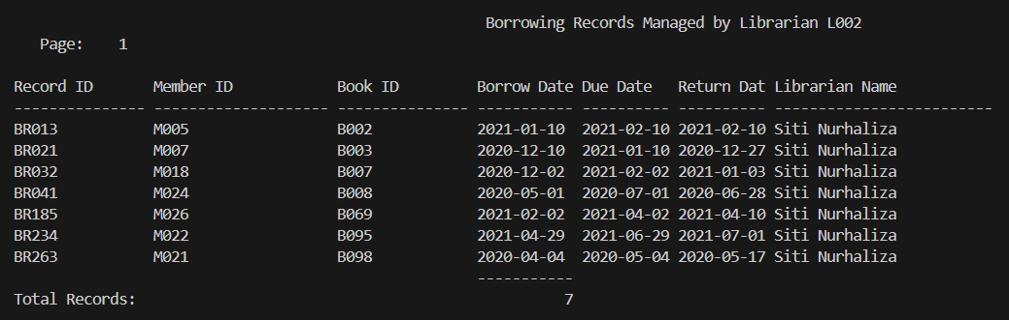

4.1.2 Query 2 : Highest Reserved Books Report

Purpose :
This query retrieves the top 5 most reserved books from a library within a specified date range. It shows the book title, category, and the total number of reservations made for each book. The query helps to identify popular books in the library based on reservation data, providing insights into reading trends and resource demand during the given period.

SQL statement :
SET LINESIZE 150
SET VERIFY OFF
SET PAGESIZE 50

-- Prompt inputs
ACCEPT Start_Date DATE FORMAT 'YYYY-MM-DD' PROMPT 'Enter Start Date (YYYY-MM-DD): '
ACCEPT End_Date DATE FORMAT 'YYYY-MM-DD' PROMPT 'Enter End Date (YYYY-MM-DD): '

-- Column formatting
COL "Book Title" FORMAT A50 HEADING 'Book Title'
COL "Category" FORMAT A20 HEADING 'Category'
COL "Total Reserved" FORMAT 9999 HEADING 'Total Reserved'

-- Report title
TTITLE CENTER 'Top 5 Most Reserved Books between &Start_Date and &End_Date' RIGHT 'Page: ' FORMAT 999 SQL.PNO SKIP 2

-- Grouping and totals
BREAK ON REPORT
COMPUTE SUM LABEL 'Total Reservations:' OF "Total Reserved" ON REPORT

-- Main query
SELECT * FROM (
SELECT
bt.Title AS "Book Title",
bt.Category AS "Category",
COUNT(br.BookReserveID) AS "Total Reserved"
FROM BookReservation br
JOIN Book b ON br.BookID = b.BookID
JOIN BookTitle bt ON b.BookID = bt.BookID
WHERE br.ReservationDate BETWEEN TO_DATE('&Start_Date', 'YYYY-MM-DD')
AND TO_DATE('&End_Date', 'YYYY-MM-DD')
AND br.Status IN ('Placed', 'Ready', 'Fulfilled')
GROUP BY bt.Title, bt.Category
ORDER BY COUNT(br.BookReserveID) DESC
)
WHERE ROWNUM <= 5;

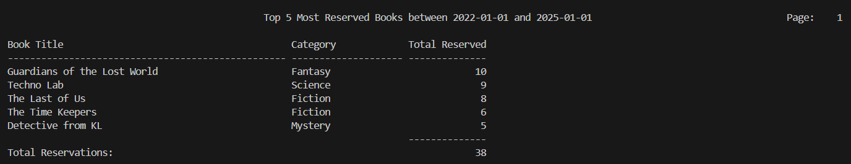
Sample Output :

4.1.3 Procedure 1: Membership Renewal Procedure
Purpose :
The purpose of this procedure is to renew a member's membership by updating their status to 'Active' and extending their expiration date by one year. It also generates a unique billing ID and inserts a billing record into the system for the renewal fee based on the member's type (Standard or Premium), ensuring that the payment status is marked as 'Unpaid'.

Procedure code :
CREATE OR REPLACE PROCEDURE RenewMembership (
p_MemberID VARCHAR2
) AS
v_MemberType VARCHAR2(10);
v_Amount NUMBER;
v_BillingID VARCHAR2(10);
BEGIN
SELECT MemberType INTO v_MemberType FROM Member WHERE MemberID = p_MemberID;

IF v_MemberType = 'Standard' THEN
v_Amount := 5;
ELSE
v_Amount := 10;
END IF;

UPDATE Member SET
ExpiryDate = ADD_MONTHS(SYSDATE, 12),
Status = 'Active'
WHERE MemberID = p_MemberID;

-- Generate Billing ID like BL001, BL002, etc.
SELECT 'BL' || TO_CHAR(BillingSeq.NEXTVAL, 'FM000') INTO v_BillingID FROM dual;

INSERT INTO Billing VALUES (
v_BillingID, p_MemberID, 'RenewMember', v_Amount, SYSDATE, 'Unpaid'
);
END;

exec RENEWMEMBERSHIP('M009');

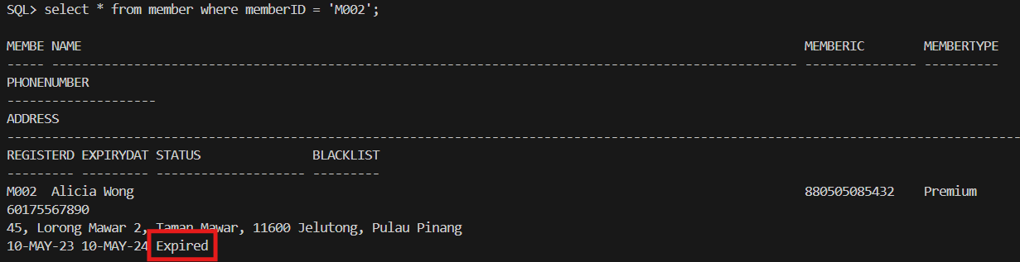
Sample Output :

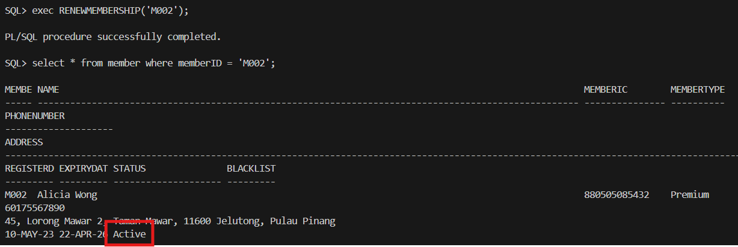

4.1.4 Procedure 2 : Generate Invoice for Billing
Purpose :
The purpose of this procedure is to generate an invoice for a billing record that has been confirmed as 'Unpaid'. It first checks if the payment status of the specified billing record is 'Unpaid'. If so, it generates a new invoice ID, inserts a record into the Invoice table with the payment details (payment date, method, and billing ID), and updates the billing status to 'Paid'. It also handles error checking, ensuring the billing record exists and the payment status is valid.

Procedure code :
CREATE OR REPLACE PROCEDURE GenerateInvoice (
p_billingID IN VARCHAR2, -- Billing ID associated with the payment
p_paymentDate IN DATE, -- Payment date
p_paymentMethod IN VARCHAR2 -- Payment method (e.g., 'Cash', 'Online Banking', 'e-wallet')
)
IS
v_invoiceID VARCHAR2(20);
v_billingStatus VARCHAR2(30);
v_memberID VARCHAR2(20);
BEGIN
-- 1. Check if the billing record exists and payment status is confirmed
SELECT PayStatus, MemberID
INTO v_billingStatus, v_memberID
FROM Billing
WHERE BillingID = p_billingID;

-- 2. Verify the payment status (e.g., paid)
IF v_billingStatus != 'Unpaid' THEN
RAISE_APPLICATION_ERROR(-20001, 'Billing has not been paid yet.');
END IF;

-- 3. Generate a new invoice ID using the sequence
SELECT 'IV' || TO_CHAR(seq_invoice_id.NEXTVAL) INTO v_invoiceID FROM dual;

-- 4. Insert the new invoice record
INSERT INTO Invoice (InvoiceID, PaymentDate, PaymentMethod, BillingID)
VALUES (v_invoiceID, p_paymentDate, p_paymentMethod, p_billingID);

-- 5. Update the billing status to 'Invoiced' after the invoice is generated
UPDATE Billing
SET PayStatus = 'Paid'
WHERE BillingID = p_billingID;

COMMIT;

-- 6. Output the generated invoice ID
DBMS_OUTPUT.PUT_LINE('Invoice generated successfully with InvoiceID: ' || v_invoiceID);
EXCEPTION
WHEN NO_DATA_FOUND THEN
RAISE_APPLICATION_ERROR(-20002, 'Billing ID not found.');
WHEN OTHERS THEN
ROLLBACK;
RAISE;
END;

exec GENERATEINVOICE('BL136',TO_DATE('2025-04-23','YYYY-MM-DD'),'Cash');

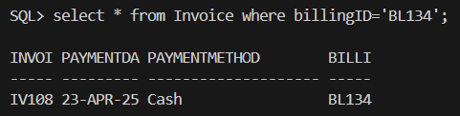
Sample Output :

4.1.5 Trigger 1 : Limit Loan Extension
Purpose :
The purpose of this trigger is to prevent a loan from being extended more than once. It fires before an update is made to the ExtensionLoan field in the BorrowingRecord table. If an attempt is made to extend a loan again after it has already been extended once, the trigger raises an error with the message 'Loan has already been extended once.'

Trigger code :
CREATE OR REPLACE TRIGGER trg_ExtendLoanOnlyOnce
BEFORE UPDATE OF ExtensionLoan ON BorrowingRecord
FOR EACH ROW
BEGIN
IF :NEW.ExtensionLoan = 'Yes' AND :OLD.ExtensionLoan = 'Yes' THEN
RAISE_APPLICATION_ERROR(-20008, 'Loan has already been extended once.');
END IF;
END;

4.1.6 Trigger 2: Prevent Borrowing for Invalid Members
Purpose :
The purpose of this trigger is to prevent members with an 'Expired' or 'Blacklisted' status from borrowing books. Before inserting a new record into the BorrowingRecord table, the trigger checks the member’s status. If the member's status is either 'Expired' or 'Blacklisted', the trigger raises an error with a message indicating that the member is not allowed to borrow books.

Trigger code:
CREATE OR REPLACE TRIGGER trg_PreventBorrowingInvalid
BEFORE INSERT ON BorrowingRecord
FOR EACH ROW
DECLARE
v_status VARCHAR2(20);
BEGIN
SELECT Status INTO v_status FROM Member WHERE MemberID = :NEW.MemberID;

IF v_status IN ('Expired', 'Blacklisted') THEN
RAISE_APPLICATION_ERROR(-20010, 'Member is not allowed to borrow books due to status: ' || v_status);
END IF;
END;

4.1.7 Report 1: Technician Maintenance Requests Report
Purpose :
This report retrieves and displays maintenance requests assigned to each technician. It loops through all technicians and lists the requests assigned to them, including request IDs, statuses, and request dates. If a technician has no assigned requests, it outputs "No requests assigned." The report is designed for use with DBMS_OUTPUT, making it suitable for output in environments such as SQL*Plus.

Report code :
CREATE OR REPLACE PROCEDURE Report_Technician_Requests AS
CURSOR tech_cur IS
SELECT TechnicianID, Name FROM Technician;

CURSOR req_cur(p_TechID Technician.TechnicianID%TYPE) IS
SELECT RequestID, Status, RequestDate
FROM MaintenanceRequest
WHERE TechnicianID = p_TechID;

BEGIN
DBMS_OUTPUT.PUT_LINE('Technician Maintenance Requests Report');
DBMS_OUTPUT.PUT_LINE('=========================================');

FOR t IN tech_cur LOOP
DBMS_OUTPUT.PUT_LINE(CHR(10) || '👷 Technician: ' || t.Name);
DBMS_OUTPUT.PUT_LINE('-----------------------------------------');

-- Check if technician has requests
DECLARE
v_found BOOLEAN := FALSE;
BEGIN
FOR r IN req_cur(t.TechnicianID) LOOP
v_found := TRUE;
DBMS_OUTPUT.PUT_LINE(' - Request ID : ' || r.RequestID);
DBMS_OUTPUT.PUT_LINE(' Status : ' || r.Status);
DBMS_OUTPUT.PUT_LINE(' Date : ' || TO_CHAR(r.RequestDate, 'YYYY-MM-DD'));
END LOOP;

IF NOT v_found THEN
DBMS_OUTPUT.PUT_LINE(' No requests assigned.');
END IF;
END;
END LOOP;

DBMS_OUTPUT.PUT_LINE(CHR(10) || '============================ END OF REPORT ============================');
END;
/

BEGIN
Report_Technician_Requests;
END;
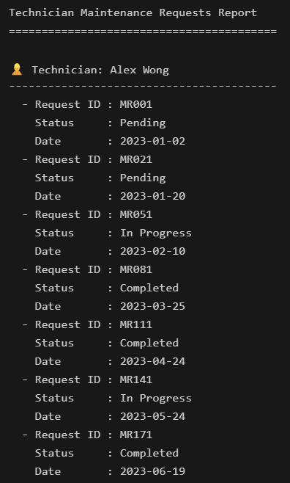
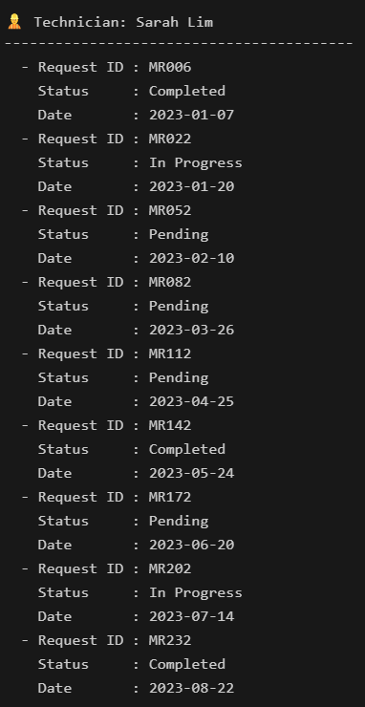
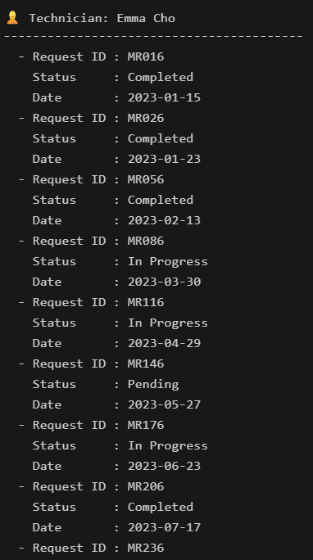
Sample Output :

4.1.8 Report 2 : Members with Overdue Books and Active Reservations Report
Purpose :
This report identifies members who have overdue books and checks if they have active reservations. It lists each member with overdue books, indicating whether they have any active reservations. The report provides a summary of members with overdue books and helps in identifying users who may be violating borrowing rules by having overdue books while still having active reservations.

Report code :
/* Report 6: Members with Multiple Overdue Books and Active Reservations */
/* XY */
CREATE OR REPLACE PROCEDURE Report_OverdueMemsActiveRsv AS
-- Cursor to fetch members who have overdue books
CURSOR overdue_mem_cur IS
SELECT MemberID, Name
FROM Member
WHERE MemberID IN (
SELECT DISTINCT MemberID
FROM BorrowingRecord
WHERE Status = 'Overdue'
);

-- Cursor to fetch the count of active reservations for each member
CURSOR active_reservation_cur(p_MemberID Member.MemberID%TYPE) IS
SELECT COUNT(*) AS ActiveReservations
FROM BookReservation
WHERE MemberID = p_MemberID AND Status = 'Placed';

BEGIN
-- Print the report title
DBMS_OUTPUT.PUT_LINE('📚📅 Overdue Members with Active Reservations Report 📊');
DBMS_OUTPUT.PUT_LINE('=====================================================');

-- Loop through all overdue members
FOR m IN overdue_mem_cur LOOP
DBMS_OUTPUT.PUT_LINE(CHR(10) || '👤 Member: ' || m.Name || ' (ID: ' || m.MemberID || ')');
DBMS_OUTPUT.PUT_LINE('-----------------------------------------------------');

-- Check if the member has any active reservations
FOR r IN active_reservation_cur(m.MemberID) LOOP
IF r.ActiveReservations > 0 THEN
DBMS_OUTPUT.PUT_LINE(' ⚠️ Has ' || r.ActiveReservations || ' active reservations but has overdue books.');
ELSE
DBMS_OUTPUT.PUT_LINE(' ✅ No active reservations, but has overdue books.');
END IF;
END LOOP;

DBMS_OUTPUT.PUT_LINE('-----------------------------------------------------');
END LOOP;

-- Print the footer design with emojis
DBMS_OUTPUT.PUT_LINE(CHR(10) || '=================== END OF REPORT ===================');
DBMS_OUTPUT.PUT_LINE('✅ Report Generated Successfully!');
END;
/

BEGIN
REPORT_OVERDUEMEMSACTIVERSV;
END;

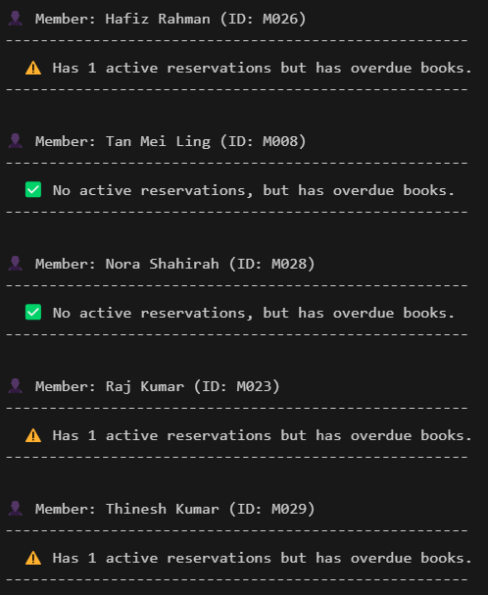
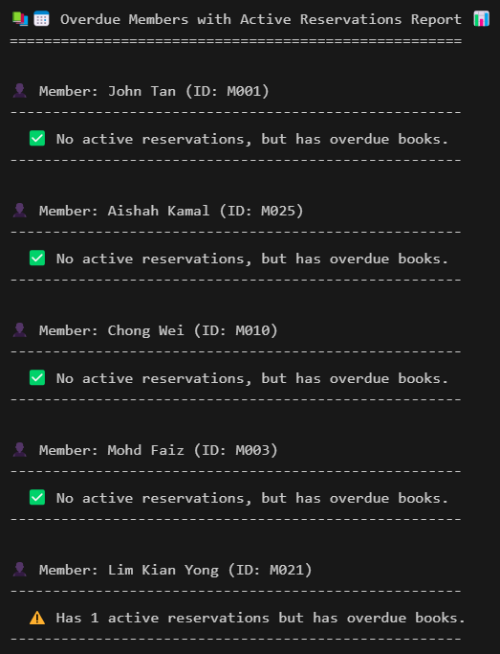
Sample Output :

4.2 LIM YEE SYUEN

4.2.1 Query 1 : Technician Maintenance History Report
Purpose :
This query generates a detailed report of maintenance requests assigned to a specific technician within a given date range. It includes the request ID, technician's name, resource details (resource ID and resource name), request date, and the status of each maintenance request. The report helps in tracking the technician's workload and the status of the maintenance tasks they have handled during the specified period.

SQL statement :
SET LINESIZE 150
SET PAGESIZE 50
SET VERIFY OFF
CLEAR COLUMNS
CLEAR BREAKS
CLEAR COMPUTES

-- Accept input parameters from user
ACCEPT tech_id CHAR PROMPT 'Enter Technician ID (e.g.T001): '
ACCEPT start_date DATE FORMAT 'YYYY-MM-DD' PROMPT 'Enter Start Date (YYYY-MM-DD): '
ACCEPT end_date DATE FORMAT 'YYYY-MM-DD' PROMPT 'Enter End Date (YYYY-MM-DD): '

-- Format columns
COLUMN "Request ID" FORMAT A12 HEADING 'Request|ID'
COLUMN "Technician Name" FORMAT A20 HEADING 'Technician|Name'
COLUMN "Resource ID" FORMAT A12 HEADING 'Resource|ID'
COLUMN "Resource Name" FORMAT A30 HEADING 'Resource|Name'
COLUMN "Request Date" FORMAT A20 HEADING 'Request|Date'
COLUMN "Status" FORMAT A15 HEADING 'Status'

-- Report Title
TTITLE CENTER 'Maintenance History Report' SKIP 1 -
CENTER 'For Technician ID: &tech_id' SKIP 1 -
CENTER 'From &start_date to &end_date' RIGHT 'Page: ' FORMAT 999 SQL.PNO SKIP 2

BREAK ON "Technician Name"
COMPUTE COUNT LABEL 'Total Record(s):' OF "Status" ON "Technician Name"

-- Main query
SELECT
mr.RequestID AS "Request ID",
t.Name AS "Technician Name", -- Removed TechnicianID
lr.ResourceID AS "Resource ID",
lr.ResourceName AS "Resource Name",
TO_CHAR(mr.RequestDate, 'YYYY-MM-DD') AS "Request Date",
mr.Status AS "Status"
FROM
MaintenanceRequest mr
JOIN
Technician t ON mr.TechnicianID = t.TechnicianID
JOIN
LibraryResource lr ON mr.ResourceID = lr.ResourceID
WHERE
mr.TechnicianID = '&tech_id'
AND mr.RequestDate BETWEEN TO_DATE('&start_date', 'YYYY-MM-DD')
AND TO_DATE('&end_date', 'YYYY-MM-DD')
ORDER BY
mr.RequestDate;

-- End of report
TTITLE OFF

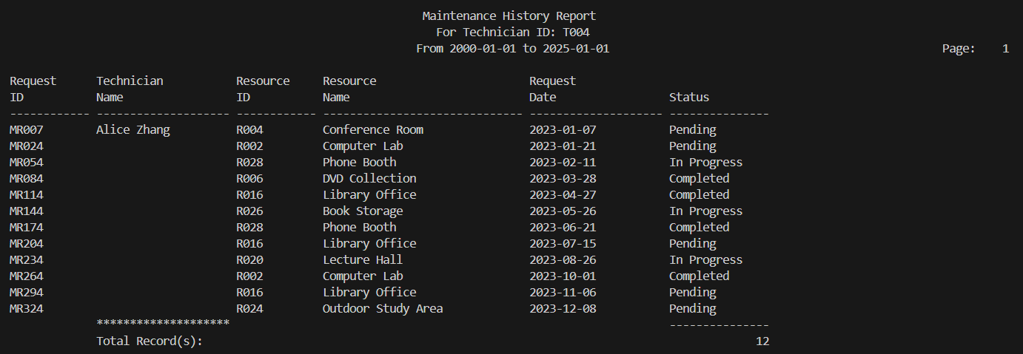
Sample Output :

4.2.1 Query 2 : Borrowed Books by Category Report
Purpose :
This query generates a report that lists all books borrowed by category within a specified date range. It provides details about the book category, member ID, member name, book ID, and the borrow date. The report helps track the borrowing trends within different book categories and is useful for library management to monitor borrowing activities by genre.

SQL statement :
SET LINESIZE 150
SET VERIFY OFF
SET PAGESIZE 50

-- Prompt input for the date range and book category
ACCEPT Start_Date DATE FORMAT 'YYYY-MM-DD' PROMPT 'Enter Start Date (YYYY-MM-DD): '
ACCEPT End_Date DATE FORMAT 'YYYY-MM-DD' PROMPT 'Enter End Date (YYYY-MM-DD): '
ACCEPT Category CHAR PROMPT 'Enter Book Category (Fiction/Comic/Mystery/Science/Fantasy): '

-- Column formatting
COL "Book Category" FORMAT A20 HEADING 'Book Category'
COL "Member ID" FORMAT A20 HEADING 'Member ID'
COL "Member Name" FORMAT A30 HEADING 'Member Name'
COL "Book ID" FORMAT A10 HEADING 'Book ID'
COL "Borrow Date" FORMAT A18 HEADING 'Borrow Date'

-- Title
TTITLE CENTER 'Books Borrowed by Category within &Start_Date and &End_Date' RIGHT 'Page: ' FORMAT 999 SQL.PNO SKIP 2

-- Break settings
BREAK ON 'Book Category'
COMPUTE COUNT LABEL 'Total Record(s):' OF "Borrow Date" ON 'Book Category'

-- Main query
SELECT
bt.Category AS "Book Category",
br.MemberID AS "Member ID",
m.Name AS "Member Name",
br.BookID AS "Book ID",
TO_CHAR(br.BorrowDate, 'YYYY-MM-DD') AS "Borrow Date"
FROM BorrowingRecord br
JOIN Member m ON br.MemberID = m.MemberID
JOIN BookTitle bt ON br.BookID = bt.BookID
WHERE bt.Category = '&Category'
AND br.BorrowDate BETWEEN TO_DATE('&Start_Date', 'YYYY-MM-DD') AND TO_DATE('&End_Date', 'YYYY-MM-DD')
ORDER BY br.BorrowDate;

-- End of report
TTITLE OFF

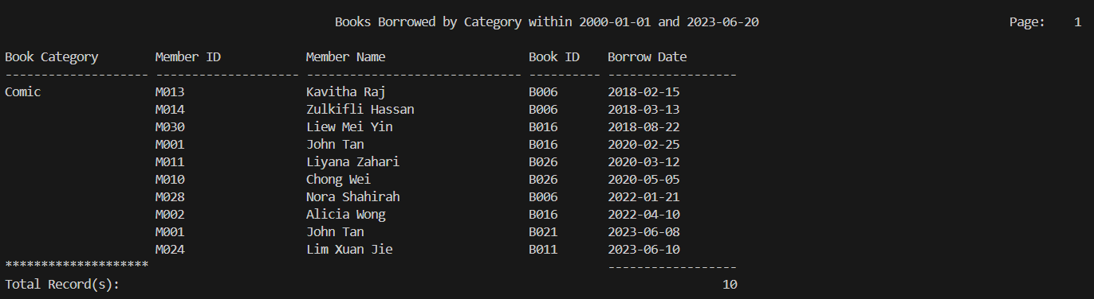
Sample Output :

4.2.3 Procedure 1 : Return Book and Handle Late Fees
Purpose :
The purpose of this procedure is to process the return of a borrowed book. It updates the return date and status of the borrowing record (marking it as 'Overdue' if returned late or 'Returned' if on time). If the book is returned late, it calculates the number of days late and generates a billing record for the overdue fee. The procedure also ensures that the member is charged appropriately for late returns.

Procedure code :
CREATE OR REPLACE PROCEDURE ReturnBook (
p_RecordID VARCHAR2
) AS
v_BookID VARCHAR2(5);
v_DueDate DATE;
v_ReturnDate DATE := SYSDATE;
v_DaysLate NUMBER;
v_BillingID VARCHAR2(10);
BEGIN
-- Get the book ID and due date from borrowing record
SELECT BookID, DueDate INTO v_BookID, v_DueDate
FROM BorrowingRecord
WHERE RecordID = p_RecordID;

-- Update the return date and status
UPDATE BorrowingRecord
SET ReturnDate = v_ReturnDate,
Status = CASE WHEN v_ReturnDate > v_DueDate THEN 'Overdue' ELSE 'Returned' END
WHERE RecordID = p_RecordID;

-- If returned late, insert billing record
IF v_ReturnDate > v_DueDate THEN
v_DaysLate := v_ReturnDate - v_DueDate;

-- Generate billing ID from sequence
v_BillingID := 'BL' || TO_CHAR(BillingSeq.NEXTVAL);

INSERT INTO Billing (
BillingID, MemberID, Type, Amount, DueDate, PayStatus
) VALUES (
v_BillingID,
(SELECT MemberID FROM BorrowingRecord WHERE RecordID = p_RecordID),
'overdue',
v_DaysLate,
v_ReturnDate,
'Unpaid'
);
END IF;
END;

exec RETURNBOOK('BR320');

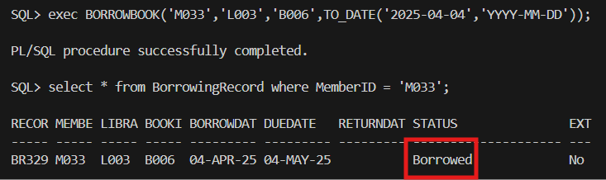
Sample Output :

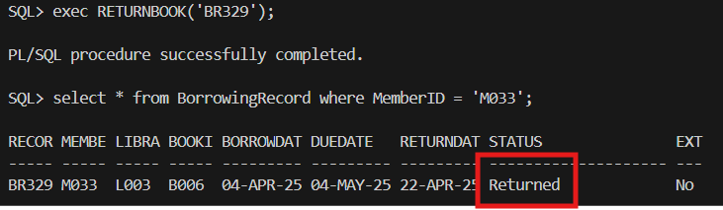

4.2.4 Procedure 2 : Reserve Book for Member
Purpose :
The purpose of this procedure is to reserve a book for a member. It checks if the member has fewer than three active reservations (with statuses 'Placed' or 'Ready'). If the member has fewer than three, the procedure proceeds by creating a reservation record and updating the book's status to 'Reserved'. If the member already has three active reservations, the procedure raises an error to prevent additional reservations.

Procedure code :
CREATE OR REPLACE PROCEDURE ReserveBook (
p_MemberID VARCHAR2,
p_BookID VARCHAR2,
p_ReserveDate DATE
) AS
v_BookReserveID VARCHAR2(10);
v_Count NUMBER;
BEGIN
-- Generate BookReserveID from the sequence
SELECT 'RE' || LPAD(seq_BookReserveID.NEXTVAL, 3, '0') INTO v_BookReserveID FROM dual;

-- Check if the member has fewer than 3 active reservations (Placed or Ready)
SELECT COUNT(*) INTO v_Count
FROM BookReservation
WHERE MemberID = p_MemberID AND Status IN ('Placed', 'Ready');

-- If the count is less than 3, proceed with the reservation
IF v_Count < 3 THEN
-- Insert the reservation record with the generated BookReserveID
INSERT INTO BookReservation (
BookReserveID, MemberID, BookID, ReservationDate, Status
) VALUES (
v_BookReserveID, p_MemberID, p_BookID, p_ReserveDate,
CASE
WHEN (SELECT Status FROM Book WHERE BookID = p_BookID) = 'Available' THEN 'Ready'
ELSE 'Placed'
END
);

-- Update book status to Reserved if it's being reserved
UPDATE Book
SET Status = 'Reserved'
WHERE BookID = p_BookID;
ELSE
RAISE_APPLICATION_ERROR(-20001, 'You cannot have more than 3 active reservations.');
END IF;
END;

exec RESERVEBOOK('M033','B006',TO_DATE('2025-03-12','YYYY-MM-DD'));

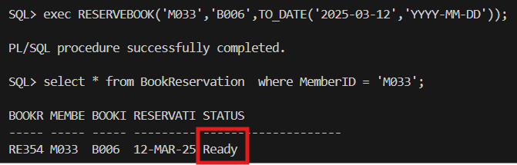
Sample Output :

4.2.5 Trigger 1 : Update Book Status and Reservation on Return
Purpose :
This trigger automatically updates the status of a book and its latest reservation when the borrowing record status is updated to 'Returned' or 'Overdue'. When a book is returned or marked as overdue, the trigger sets the book's status to 'Available' and updates the latest placed reservation for the same book to 'Ready', ensuring that the next available member can borrow the book.

Trigger code :
CREATE OR REPLACE TRIGGER trg_UpdateBookStatusOnReturn
AFTER UPDATE OF Status ON BorrowingRecord
FOR EACH ROW
WHEN (NEW.Status IN ('Returned', 'Overdue'))
BEGIN
-- Step 1: Set the book status to 'Available'
UPDATE Book
SET Status = 'Available'
WHERE BookID = :NEW.BookID;

-- Step 2: Update the latest reservation to 'Ready'
UPDATE BookReservation
SET Status = 'Ready'
WHERE BookID = :NEW.BookID
AND Status = 'Placed'
AND ReservationDate = (
SELECT MAX(ReservationDate)
FROM BookReservation
WHERE BookID = :NEW.BookID AND Status = 'Placed'
);
END;

4.2.6 Trigger 2 : Blacklist Members for Late Returns
Purpose :
This trigger automatically blacklists members who have either returned books more than 30 days late or still have unreturned books that are 30 days overdue. It updates the member's status to 'Blacklisted' and records the blacklisting date. The trigger ensures that members who repeatedly violate return deadlines are marked accordingly in the system.

Trigger code :
CREATE OR REPLACE TRIGGER trg_BlacklistMember
AFTER UPDATE OF ReturnDate, Status ON BorrowingRecord
DECLARE
BEGIN
-- Blacklist members who returned books more than 30 days late
UPDATE Member
SET Status = 'Blacklisted',
BlackListDate = SYSDATE
WHERE MemberID IN (
SELECT br.MemberID
FROM BorrowingRecord br
WHERE br.ReturnDate IS NOT NULL
AND br.ReturnDate > br.DueDate + 30
)
AND Status != 'Blacklisted';

-- Blacklist members who still have not returned the book after 30 days past due
UPDATE Member
SET Status = 'Blacklisted',
BlackListDate = SYSDATE
WHERE MemberID IN (
SELECT br.MemberID
FROM BorrowingRecord br
WHERE br.ReturnDate IS NULL
AND SYSDATE > br.DueDate + 30
)
AND Status != 'Blacklisted';
END;

SET SERVEROUTPUT ON;

4.2.7 Report 1 : Most Active Members Report
Purpose :
This report identifies and lists the most active members of the library based on their total borrowing and reservation activities. It calculates the total number of borrowings and reservations for each member, and includes only those who have more than 5 activities, highlighting the library's most engaged users.

Report code :
CREATE OR REPLACE PROCEDURE Report_MostActiveMembers AS
-- Cursor to fetch all members
CURSOR mem_cur IS
SELECT MemberID, Name FROM Member;

-- Cursor to count total activities (borrowings + reservations) for each member
CURSOR activity_count_cur(p_MemberID Member.MemberID%TYPE) IS
SELECT
(SELECT COUNT(*) FROM BorrowingRecord WHERE MemberID = p_MemberID) +
(SELECT COUNT(*) FROM BookReservation WHERE MemberID = p_MemberID) AS TotalActivity
FROM DUAL;

BEGIN
-- Print the report header
DBMS_OUTPUT.PUT_LINE('📊 Most Active Members Report 🚀');
DBMS_OUTPUT.PUT_LINE('====================================================');

-- Loop through all members
FOR m IN mem_cur LOOP
FOR a IN activity_count_cur(m.MemberID) LOOP
-- Check if member has more than 5 total activities
IF a.TotalActivity > 5 THEN
DBMS_OUTPUT.PUT_LINE(CHR(10) || '🌟 Active Member: ' || m.Name || ' (ID: ' || m.MemberID || ')');
DBMS_OUTPUT.PUT_LINE(' - Total Activities: ' || a.TotalActivity);
DBMS_OUTPUT.PUT_LINE(' -----------------------------------------------');
END IF;
END LOOP;
END LOOP;

-- Print the footer design
DBMS_OUTPUT.PUT_LINE(CHR(10) || '=================== END OF REPORT ===================');
DBMS_OUTPUT.PUT_LINE('✅ Report Generated Successfully!');
END;
/

BEGIN
Report_MostActiveMembers;
END;
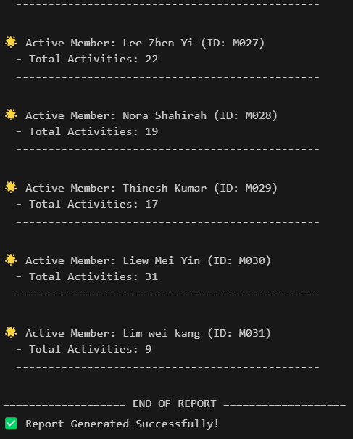
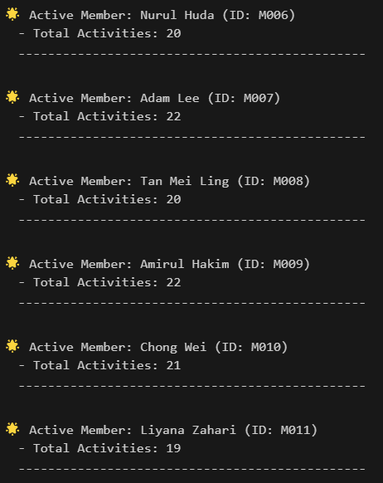
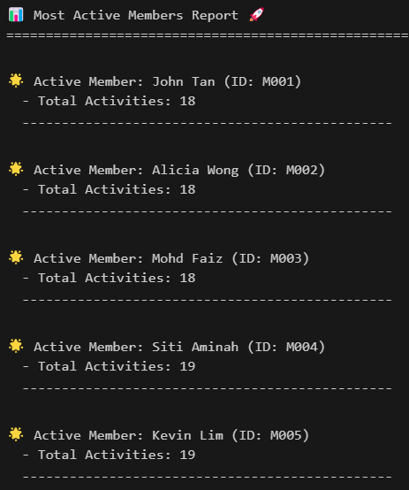
Sample Output :

4.2.8 Report 2 : Detail Report of Facility Reservations by Member
Purpose :
This report generates a detailed listing of facility reservations made by each member. It provides the member’s name, ID, and the details of the resources they have reserved, including the resource name and reservation date. If a member has no reservations, the report will indicate that no reservations were found for them.

Report code :
CREATE OR REPLACE PROCEDURE Report_FacilityReservations AS
CURSOR mem_cur IS
SELECT MemberID, Name FROM Member;

CURSOR res_cur(p_MemberID Member.MemberID%TYPE) IS
SELECT fr.ResourceID, fr.ReservationDate, lr.ResourceName
FROM FacilityReservation fr
JOIN LibraryResource lr ON fr.ResourceID = lr.ResourceID
WHERE fr.MemberID = p_MemberID;

BEGIN
-- Header
DBMS_OUTPUT.PUT_LINE('🏢 Facility Reservation Report');
DBMS_OUTPUT.PUT_LINE('===============================================');

FOR m IN mem_cur LOOP
DBMS_OUTPUT.PUT_LINE('👤 Member: ' || m.Name || ' (ID: ' || m.MemberID || ')');

DECLARE
has_reservation BOOLEAN := FALSE;
BEGIN
FOR r IN res_cur(m.MemberID) LOOP
has_reservation := TRUE;
DBMS_OUTPUT.PUT_LINE(' 🔹 Reserved: ' || r.ResourceName || ' 📅 Date: ' || r.ReservationDate);
END LOOP;

IF NOT has_reservation THEN
DBMS_OUTPUT.PUT_LINE(' ⚠️ No reservations found.');
END IF;
END;

DBMS_OUTPUT.PUT_LINE('-----------------------------------------------');
END LOOP;

-- Footer
DBMS_OUTPUT.PUT_LINE('✅ End of Report.');
END;
/

BEGIN
Report_FacilityReservations;
END;

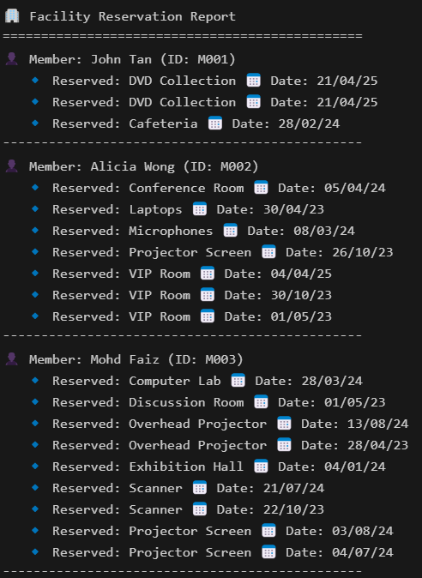
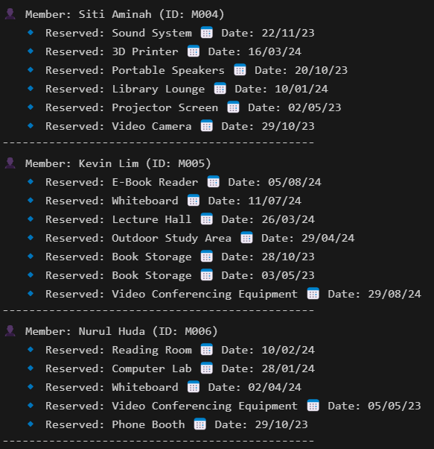
Sample Output :

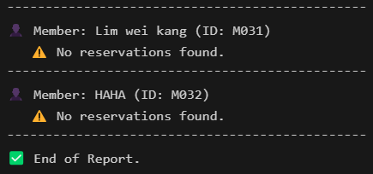

4.3 LIM WEI KANG

4.3.1 Query 1: Books Borrowed by Members
Purpose :
This query generates a formatted report of books borrowed by members within a specified date range. It prompts for start and end dates, retrieves relevant borrowing records, and displays member details, borrow and return dates, and status. The output is grouped by member, includes record counts, and is sorted by Member ID and Borrow Date for clear presentation.

SQL statement :
SET LINESIZE 150
SET VERIFY OFF
SET PAGESIZE 50

-- Prompt inputs
ACCEPT Start_Date DATE FORMAT 'YYYY-MM-DD' PROMPT 'Enter Start Date (YYYY-MM-DD): '
ACCEPT End_Date DATE FORMAT 'YYYY-MM-DD' PROMPT 'Enter End Date (YYYY-MM-DD): '

-- Column formatting
COL "Member ID" FORMAT A15 HEADING 'Member ID'
COL "Member Name" FORMAT A30 HEADING 'Member Name'
COL "Borrow Date" FORMAT A15 HEADING 'Borrow Date'
COL "Due Date" FORMAT A15 HEADING 'Due Date'
COL "Return Date" FORMAT A15 HEADING 'Return Date'
COL "Status" FORMAT A20 HEADING 'Status'

-- Report title
TTITLE CENTER 'Books Borrowed by Members between &Start_Date and &End_Date' RIGHT 'Page: ' FORMAT 999 SQL.PNO SKIP 2

-- Grouping and line break after each MemberID group
BREAK ON "Member ID" ON "Member Name" SKIP 1
COMPUTE COUNT LABEL 'Total Record(s):' OF "Status" ON "Member ID"

-- Main query
SELECT
m.MemberID AS "Member ID",
m.Name AS "Member Name",
TO_CHAR(br.BorrowDate, 'YYYY-MM-DD') AS "Borrow Date",
TO_CHAR(br.DueDate, 'YYYY-MM-DD') AS "Due Date",
TO_CHAR(br.ReturnDate, 'YYYY-MM-DD') AS "Return Date",
br.Status AS "Status"
FROM BorrowingRecord br
JOIN Member m ON br.MemberID = m.MemberID
JOIN BookTitle bt ON br.BookID = bt.BookID
WHERE br.BorrowDate BETWEEN TO_DATE('&Start_Date', 'YYYY-MM-DD') AND TO_DATE('&End_Date', 'YYYY-MM-DD')
ORDER BY m.MemberID, br.BorrowDate;

-- Cleanup
CLEAR COLUMNS
TTITLE OFF

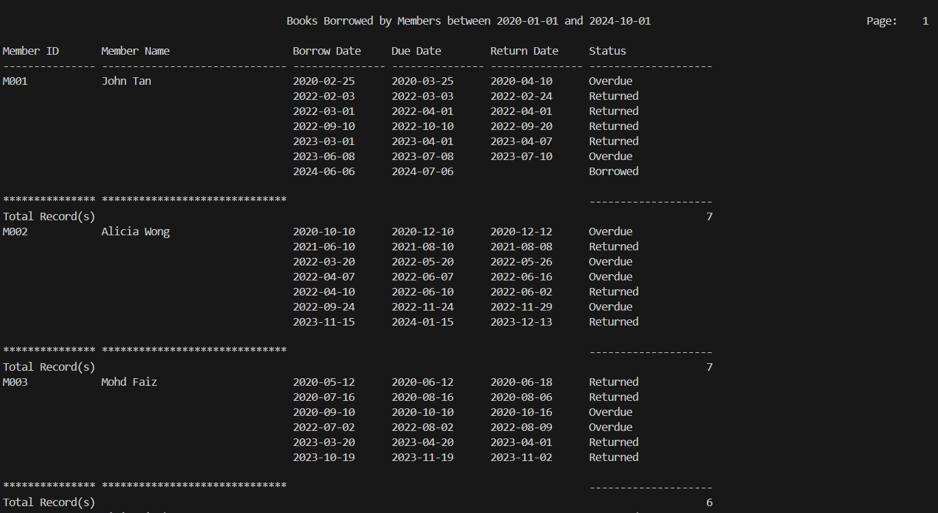
Sample Output :

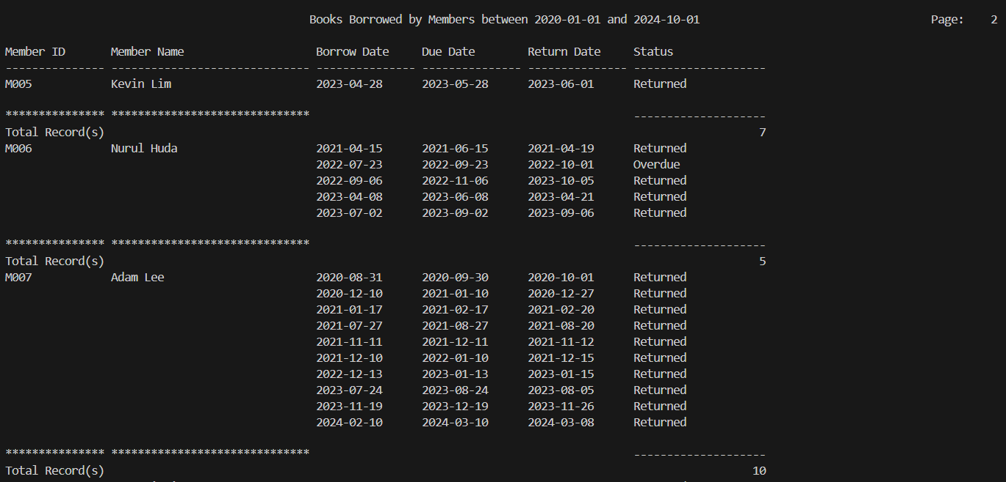

4.3.2 Query 2 : Members Using Resource
Purpose :
This query generates a report showing which members used a specific resource within a given date range. It prompts the user to enter a Resource ID, Start Date, and End Date, then displays the resource name, member details, and reservation dates. The output is grouped by resource and includes a total count of reservations.

SQL statement :
SET LINESIZE 150
SET VERIFY OFF
SET PAGESIZE 50

-- Prompt inputs
ACCEPT Resource_ID CHAR PROMPT 'Enter Resource ID (e.g., R001): '
ACCEPT Start_Date DATE FORMAT 'YYYY-MM-DD' PROMPT 'Enter Start Date (YYYY-MM-DD): '
ACCEPT End_Date DATE FORMAT 'YYYY-MM-DD' PROMPT 'Enter End Date (YYYY-MM-DD): '

-- Column formatting
COL "Resource Name" FORMAT A30 HEADING 'Resource Name'
COL "Member ID" FORMAT A10 HEADING 'Member ID'
COL "Member Name" FORMAT A30 HEADING 'Member Name'
COL "Reservation Date" FORMAT A20 HEADING 'Reservation Date'

-- Report title
TTITLE CENTER 'Members Using Resource &Resource_ID from &Start_Date to &End_Date' RIGHT 'Page: ' FORMAT 999 SQL.PNO SKIP 2

-- Grouping and totals for reservation count
BREAK ON "Resource Name" SKIP 1
COMPUTE COUNT LABEL 'Total Record(s):' OF "Reservation Date" ON "Resource Name"

-- Main query with GROUP BY
SELECT
lr.ResourceName AS "Resource Name",
m.MemberID AS "Member ID",
m.Name AS "Member Name",
TO_CHAR(fr.ReservationDate, 'YYYY-MM-DD') AS "Reservation Date"
FROM FacilityReservation fr
JOIN LibraryResource lr ON fr.ResourceID = lr.ResourceID
JOIN Member m ON fr.MemberID = m.MemberID
WHERE fr.ResourceID = '&Resource_ID'
AND fr.ReservationDate BETWEEN TO_DATE('&Start_Date', 'YYYY-MM-DD') AND TO_DATE('&End_Date', 'YYYY-MM-DD')
ORDER BY lr.ResourceName, fr.ReservationDate;

-- Cleanup
CLEAR COLUMNS
TTITLE OFF

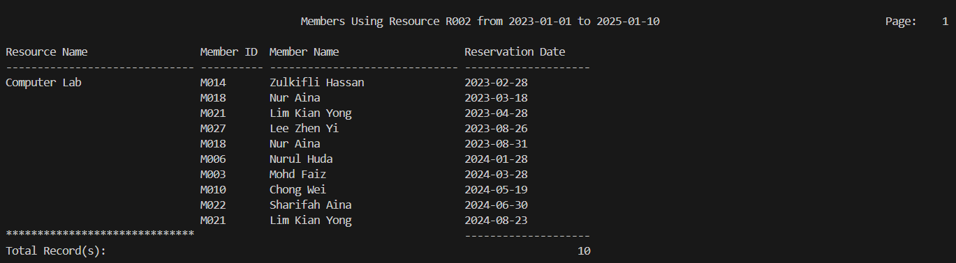
Sample Output:

4.3.3 Procedure 1: Borrowing Control and Record Insertion
Purpose :
This procedure allows a member to borrow a book by checking their membership type and applying borrowing limits. It verifies the number of active borrowings, ensures the member is within the allowed limit, inserts a new borrowing record with a due date, and updates the book’s status and borrow count. If the limit is exceeded, it raises an error.

Procedure code :
CREATE OR REPLACE PROCEDURE BorrowBook (
p_MemberID VARCHAR2,
p_LibrarianID VARCHAR2,
p_BookID VARCHAR2,
p_BorrowDate DATE
) AS
v_Limit NUMBER;
v_Count NUMBER;
v_Duration NUMBER;
v_Status VARCHAR2(20);
v_RecordID VARCHAR2(10);
BEGIN
-- Get member type
SELECT MemberType INTO v_Status
FROM Member
WHERE MemberID = p_MemberID;

-- Set borrowing rules
IF v_Status = 'Standard' THEN
v_Limit := 2;
v_Duration := 30;
ELSE
v_Limit := 5;
v_Duration := 60;
END IF;

-- Count current active borrowings
SELECT COUNT(*) INTO v_Count
FROM BorrowingRecord
WHERE MemberID = p_MemberID AND Status = 'Borrowed';

-- If within limit
IF v_Count < v_Limit THEN
-- Generate new record ID
v_RecordID := 'BR' || LPAD(seq_BorrowingRecordID.NEXTVAL, 3, '0');

-- Insert new borrowing record using custom borrow date
INSERT INTO BorrowingRecord VALUES (
v_RecordID, p_MemberID, p_LibrarianID, p_BookID,
p_BorrowDate, p_BorrowDate + v_Duration, NULL, 'Borrowed', 'No'
);

-- Set book status to reserved
UPDATE Book
SET Status = 'Reserved',
BorrowedCount = NVL(BorrowedCount, 0) + 1
WHERE BookID = p_BookID;
ELSE
RAISE_APPLICATION_ERROR(-20001, 'You have reached your borrowing limit.');
END IF;
END;

exec BORROWBOOK('M004','L003','B006',TO_DATE('2025-04-04','YYYY-MM-DD'));

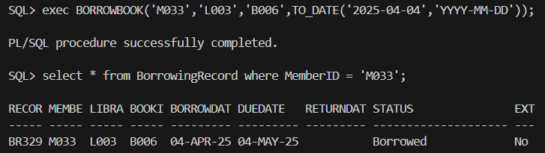
Sample Output:

4.3.4 Procedure 2: Validated Facility Reservation Entry
Purpose :
This procedure inserts a facility reservation after validating the resource’s status and type. It ensures the resource is available and of type 'Facility', and restricts VIP room (R030) reservations to Premium members only. Upon passing all checks, it generates a new reservation ID and inserts the reservation with status 'Ready'. It also handles exceptions for missing data or errors during execution.

Procedure code :
CREATE OR REPLACE PROCEDURE InsertFacilityReservation (
p_memberID IN VARCHAR2,
p_resourceID IN VARCHAR2,
p_reservationDate IN DATE
)
IS
v_resource_status VARCHAR2(30);
v_member_type VARCHAR2(20);
v_resource_type VARCHAR2(30);
v_new_reservationID VARCHAR2(20);
BEGIN
-- 1. Check if resource exists and get its status and type
SELECT LibraryResourceStatus, ResourceType INTO v_resource_status, v_resource_type
FROM LibraryResource
WHERE ResourceID = p_resourceID;

-- 2. Validate resource status
IF v_resource_status IN ('Under Maintenance', 'Closed') THEN
RAISE_APPLICATION_ERROR(-20001, 'Resource is not available for reservation.');
END IF;

-- 3. Check if the resource is of type 'Facility' (can reserve) or 'Equipment' (cannot reserve)
IF v_resource_type = 'Equipment' THEN
RAISE_APPLICATION_ERROR(-20002, 'Only Facility can be reserved.');
END IF;

-- 4. Check if the resource is R030 and verify if the member is premium
IF p_resourceID = 'R030' THEN
-- Fetch member type
SELECT MemberType INTO v_member_type
FROM Member
WHERE MemberID = p_memberID;

IF v_member_type != 'Premium' THEN
RAISE_APPLICATION_ERROR(-20003, 'Only Premium members can reserve the VIP Room (R030).');
END IF;
END IF;

-- 5. Generate ReservationID using the sequence
v_new_reservationID := 'FR' || TO_CHAR(seq_reservation_id.NEXTVAL);

-- 6. Insert reservation with status 'Ready'
INSERT INTO FacilityReservation (
FacilityReserveID, MemberID, ResourceID, ReservationDate, reservationStatus
) VALUES (
v_new_reservationID, p_memberID, p_resourceID, p_reservationDate, 'Ready'
);

COMMIT;
EXCEPTION
WHEN NO_DATA_FOUND THEN
RAISE_APPLICATION_ERROR(-20004, 'Resource or Member does not exist.');
WHEN OTHERS THEN
ROLLBACK;
RAISE;
END;

exec INSERTFACILITYRESERVATION('M001','R006',TO_DATE('2025-04-21','YYYY-MM-DD'));

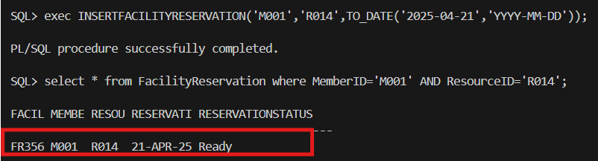
Sample Output:

4.3.5 Trigger 1 : Validate Book Reservation Fulfillment
Purpose :
This trigger ensures data consistency before a reservation's status is updated to 'Fulfilled'. It checks that the associated book is available, the previous reservation status is 'Ready', and the member is currently active. If any condition fails, an appropriate error is raised to prevent the update.

Trigger code :
CREATE OR REPLACE TRIGGER trg_UpdateBookReservedStatus
BEFORE UPDATE OF Status ON BookReservation
FOR EACH ROW
DECLARE
v_book_status VARCHAR2(20);
v_member_status VARCHAR2(20);
v_member_type VARCHAR2(10);
BEGIN
IF :NEW.Status = 'Fulfilled' THEN
SELECT Status INTO v_book_status
FROM Book
WHERE BookID = :NEW.BookID;

IF v_book_status != 'Available' THEN
RAISE_APPLICATION_ERROR(-20001, 'Book is not reserved.');
END IF;

IF :OLD.Status != 'Ready' THEN
RAISE_APPLICATION_ERROR(-20005, 'Reservation is not marked as Ready.');
END IF;

SELECT Status, MemberType INTO v_member_status, v_member_type
FROM Member
WHERE MemberID = :NEW.MemberID;

IF v_member_status != 'Active' THEN
RAISE_APPLICATION_ERROR(-20002, 'Member is either expired or blacklisted.');
END IF;
END IF;
END;

4.3.6 Trigger 2: Auto-Mark Top Borrowed Books as Popular
Purpose :
This trigger automatically updates book popularity after any insert or update on BorrowedCount. It resets all book remarks, then marks the top 3 most borrowed books (with BorrowedCount > 10) in each category as 'Popular' using dense ranking.

Trigger code :
CREATE OR REPLACE TRIGGER trg_UpdatePopularBooks
AFTER INSERT OR UPDATE OF BorrowedCount ON Book
DECLARE
BEGIN
-- Step 1: Reset all Remarks
UPDATE Book
SET Remark = NULL;

-- Step 2: Mark top 3 popular books in each category with BorrowedCount > 10
MERGE INTO Book b
USING (
SELECT BookID
FROM (
SELECT b.BookID,
bt.Category,
DENSE_RANK() OVER (PARTITION BY bt.Category ORDER BY b.BorrowedCount DESC) AS rnk
FROM Book b
JOIN BookTitle bt ON b.BookID = bt.BookID
WHERE b.BorrowedCount > 10
)
WHERE rnk <= 3
) top_books
ON (b.BookID = top_books.BookID)
WHEN MATCHED THEN
UPDATE SET b.Remark = 'Popular';
END;

4.3.7 Report 1 : Top Borrowing Members by Category
Purpose :
This report lists the top borrowers for each book category. It uses cursors to loop through each category and display members who borrowed the most books in that category, sorted in descending order. If no borrowers are found, a message is shown accordingly.

Report code :
CREATE OR REPLACE PROCEDURE Report_MemBorrowedByCategory AS
CURSOR cat_cur IS
SELECT DISTINCT Category FROM BookTitle;

CURSOR top_borrowers_cur(p_Category BookTitle.Category%TYPE) IS
SELECT br.MemberID, m.Name, COUNT(*) AS BorrowedBooks
FROM BorrowingRecord br
JOIN BookTitle bt ON br.BookID = bt.BookID
JOIN Member m ON br.MemberID = m.MemberID
WHERE bt.Category = p_Category
GROUP BY br.MemberID, m.Name
ORDER BY BorrowedBooks DESC;

BEGIN
-- Print report header
DBMS_OUTPUT.PUT_LINE('📊 Report: Top Borrowing Members by Category');
DBMS_OUTPUT.PUT_LINE('================================================');

-- Loop through each category and display the top borrowers
FOR c IN cat_cur LOOP
DBMS_OUTPUT.PUT_LINE('Category: ' || c.Category);
DBMS_OUTPUT.PUT_LINE('---------------------------------------------');

-- Loop through top borrowers in each category
FOR b IN top_borrowers_cur(c.Category) LOOP
DBMS_OUTPUT.PUT_LINE(' - Member: ' || b.Name || ' (ID: ' || b.MemberID || ') borrowed ' || b.BorrowedBooks || ' books.');
END LOOP;

IF SQL%ROWCOUNT = 0 THEN
DBMS_OUTPUT.PUT_LINE(' No borrowers for this category.');
END IF;

DBMS_OUTPUT.PUT_LINE('---------------------------------------------');
END LOOP;

DBMS_OUTPUT.PUT_LINE('==================== END OF REPORT =====================');
END;
/

BEGIN
Report_MemBorrowedByCategory;
END;

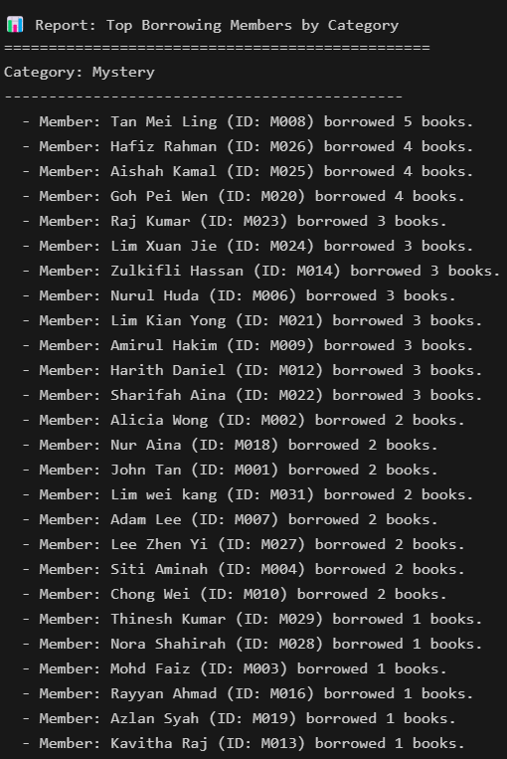
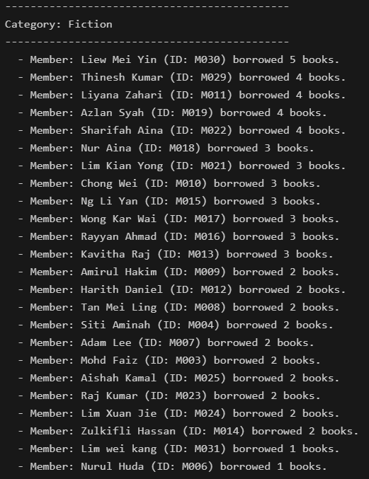
Sample Output :

4.3.8 Report 2 : Summary Report - Total Overdue Amounts by Member Type
Purpose :
This report's purpose is to generate a summary of total overdue billing amounts categorized by member type. It loops through each member type and calculates the total overdue charges for all members within that type, displaying detailed overdue amounts per member and the total for each category. If no overdue records exist for a type, a message is shown.

Report code :
CREATE OR REPLACE PROCEDURE Report_OverdueAmtByMemberType AS
CURSOR type_cur IS
SELECT MemberType FROM Member GROUP BY MemberType;

CURSOR overdue_member_cur(p_MemberType Member.MemberType%TYPE) IS
SELECT m.MemberID, m.Name, SUM(b.Amount) AS TotalOverdueAmount
FROM Billing b
JOIN Member m ON b.MemberID = m.MemberID
WHERE b.PayStatus = 'Overdue' AND m.MemberType = p_MemberType
GROUP BY m.MemberID, m.Name;

BEGIN
DBMS_OUTPUT.PUT_LINE('💰 Overdue Amount Report by Member Type');
DBMS_OUTPUT.PUT_LINE('==========================================');

FOR t IN type_cur LOOP
DBMS_OUTPUT.PUT_LINE('🧾 Member Type : ' || t.MemberType);

DECLARE
total_overdue_amount NUMBER := 0;
has_overdue BOOLEAN := FALSE;
BEGIN
FOR o IN overdue_member_cur(t.MemberType) LOOP
has_overdue := TRUE;
DBMS_OUTPUT.PUT_LINE(' 🔹 Member : ' || o.Name || ' (ID: ' || o.MemberID || ')');
DBMS_OUTPUT.PUT_LINE(' ➤ Overdue Amount: RM ' || TO_CHAR(o.TotalOverdueAmount, '9990.00'));
total_overdue_amount := total_overdue_amount + o.TotalOverdueAmount;
END LOOP;

IF has_overdue THEN
DBMS_OUTPUT.PUT_LINE(' 📌 Total Overdue for "' || t.MemberType || '" : RM ' || TO_CHAR(total_overdue_amount, '9990.00'));
ELSE
DBMS_OUTPUT.PUT_LINE(' ✅ No overdue records for this member type.');
END IF;

DBMS_OUTPUT.PUT_LINE('-------------------------------------------------');
END;
END LOOP;

DBMS_OUTPUT.PUT_LINE('✅ End of Report.');
END;
/

BEGIN
Report_OverdueAmtByMemberType;
END;

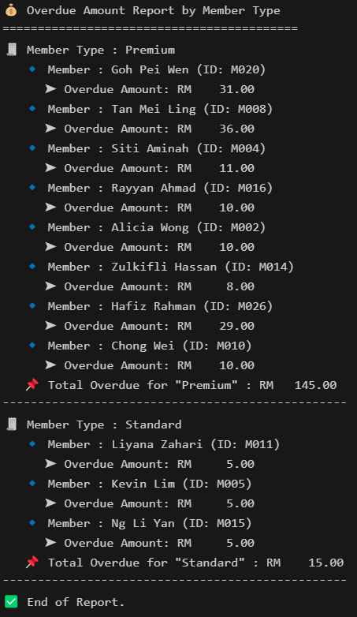
Sample Output:

4.4 NGOI WAN XUAN

4.4.1 Query 1 : Top 5 Most Borrowed Books
Purpose :
This query purpose is to generate a report showing the top 5 most borrowed books within a specified date range. It displays each book's title, author, category, average borrow days, and total times borrowed, sorted in descending order of borrow count.

SQL statement :
SET LINESIZE 150
SET VERIFY OFF
SET PAGESIZE 50

-- Prompt inputs
ACCEPT Start_Date DATE FORMAT 'YYYY-MM-DD' PROMPT 'Enter Start Date (YYYY-MM-DD): '
ACCEPT End_Date DATE FORMAT 'YYYY-MM-DD' PROMPT 'Enter End Date (YYYY-MM-DD): '

-- Column formatting
COL "Book Title" FORMAT A30 HEADING 'Book Title'
COL "Author" FORMAT A20 HEADING 'Author'
COL "Category" FORMAT A15 HEADING 'Category'
COL "Avg Borrow Days" FORMAT 9999 HEADING 'Avg Borrow Days'
COL "Total Borrowed" FORMAT 9999 HEADING 'Total Borrowed'

-- Report title
TTITLE CENTER 'Top 5 Most Borrowed Books between &Start_Date and &End_Date' RIGHT 'Page: ' FORMAT 999 SQL.PNO SKIP 2

-- Grouping and totals
BREAK ON REPORT
COMPUTE SUM LABEL 'Total Borrowed Books:' OF "Total Borrowed" ON REPORT

-- Main query
SELECT * FROM (
SELECT bt.Title AS "Book Title",
bt.Author AS "Author",
bt.Category AS "Category",
AVG(TO_NUMBER(br.DueDate - br.BorrowDate)) AS "Avg Borrow Days",
SUM(b.BorrowedCount) AS "Total Borrowed"
FROM Book b
JOIN BookTitle bt ON b.BookID = bt.BookID
JOIN BorrowingRecord br ON br.BookID = b.BookID
WHERE b.Status = 'Available'
AND br.BorrowDate BETWEEN TO_DATE('&Start_Date', 'YYYY-MM-DD') AND TO_DATE('&End_Date', 'YYYY-MM-DD')
GROUP BY bt.Title, bt.Author, bt.Category
ORDER BY SUM(b.BorrowedCount) DESC
)
WHERE ROWNUM <= 5;

-- Cleanup
CLEAR COLUMNS
TTITLE OFF

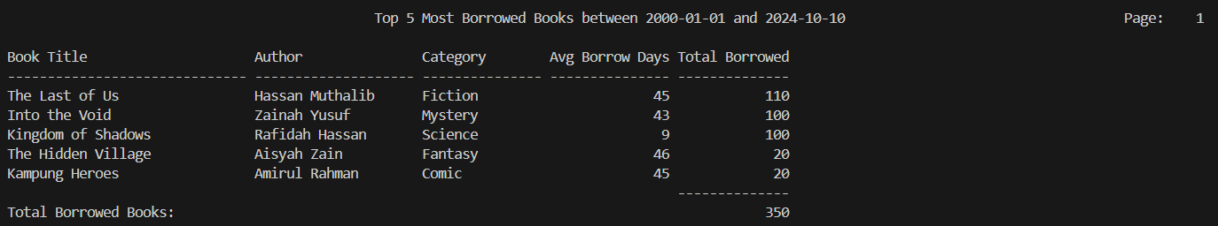
Sample Output :

4.4.2 Query 2 : Top 5 Most Frequently Reserved Facilities
Purpose :
This query purpose is to display the top 5 most reserved library facilities within a specified date range. It shows each facility's ID, name, location, and total reservation count, sorted in descending order of usage.

SQL statement:
SET LINESIZE 120
SET PAGESIZE 50
SET VERIFY OFF

-- Prompt for date range
ACCEPT start_date DATE FORMAT 'YYYY-MM-DD' PROMPT 'Enter start date (YYYY-MM-DD): '
ACCEPT end_date DATE FORMAT 'YYYY-MM-DD' PROMPT 'Enter end date (YYYY-MM-DD): '

-- Column formatting
COL "Rank" FORMAT 99 HEADING 'Rank'
COL "Resource ID" FORMAT A12 HEADING 'Resource|ID'
COL "Resource Name" FORMAT A30 HEADING 'Resource|Name'
COL "Location" FORMAT A25 HEADING 'Location'
COL "Reservation Count" FORMAT 999 HEADING 'Reservation|Count'

-- Title with date range
TTITLE CENTER 'Top 5 Most Frequently Reserved Facilities' SKIP 1 -
CENTER '(From &start_date to &end_date)' SKIP 2

-- Main query with date range filter
SELECT
ROWNUM AS "Rank",
r.ResourceID AS "Resource ID",
r.ResourceName AS "Resource Name",
r.Location,
r.ReservationCount AS "Reservation Count"
FROM (
SELECT
lr.ResourceID,
lr.ResourceName,
lr.Location,
COUNT(fr.FacilityReserveID) AS ReservationCount
FROM
LibraryResource lr
JOIN
FacilityReservation fr ON lr.ResourceID = fr.ResourceID
WHERE
lr.ResourceType = 'Facility'
AND fr.ReservationDate BETWEEN TO_DATE('&start_date', 'YYYY-MM-DD')
AND TO_DATE('&end_date', 'YYYY-MM-DD')
GROUP BY
lr.ResourceID, lr.ResourceName, lr.Location
ORDER BY
COUNT(fr.FacilityReserveID) DESC
) r
WHERE ROWNUM <= 5;

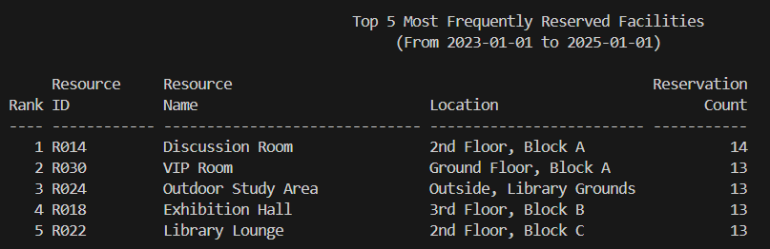
Sample Output:

4.4.3 Procedure 1 : Borrowing Due Date Extension
Purpose :
This procedure extends the due date of a borrowed item by 7 days if the current due date has not yet passed and the loan has not been extended before. It updates the BorrowingRecord by setting a new due date and marking the extension as used.

Procedure code :
CREATE OR REPLACE PROCEDURE ExtendLoan (
p_RecordID VARCHAR2
) AS
BEGIN
UPDATE BorrowingRecord
SET DueDate = DueDate + 7, ExtensionLoan = 'Yes'
WHERE RecordID = p_RecordID AND ExtensionLoan = 'No' AND SYSDATE <= DueDate;
END;

exec EXTENDLOAN('BR313');

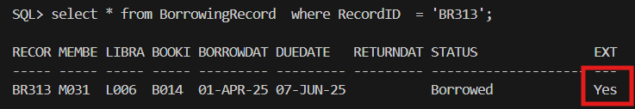
Sample Output:

4.4.4 Procedure 2 : Cancel Facility Reservation with Validation
Purpose :
This procedure cancels a facility reservation by validating its current status. It ensures the reservation exists and is not already cancelled. If valid, it updates the reservation status to 'Cancelled', changes the associated resource status to 'Available', and confirms the action. It also handles exceptions for non-existent reservations or other errors.

Procedure code :
CREATE OR REPLACE PROCEDURE CancelFacilityReservation (
p_reservationID IN VARCHAR2 -- Reservation ID to be cancelled
)
IS
v_reservationStatus VARCHAR2(30);
v_resourceID VARCHAR2(20);
BEGIN
-- 1. Check if the reservation exists and fetch the status and resource ID
SELECT ReservationStatus, ResourceID
INTO v_reservationStatus, v_resourceID
FROM FacilityReservation
WHERE facilityReserveID = p_reservationID;

-- 2. Verify if the reservation is already cancelled
IF v_reservationStatus = 'Cancelled' THEN
RAISE_APPLICATION_ERROR(-20001, 'Reservation is already cancelled.');
END IF;

-- 3. Update the reservation status to 'Cancelled'
UPDATE FacilityReservation
SET ReservationStatus = 'Cancelled'
WHERE FacilityReserveID = p_reservationID;

-- 4. If necessary, update the library resource status to 'Available'
UPDATE LibraryResource
SET LibraryResourceStatus = 'Available'
WHERE ResourceID = v_resourceID;

COMMIT;

-- 5. Output confirmation
DBMS_OUTPUT.PUT_LINE('Reservation ' || p_reservationID || ' has been successfully cancelled.');

EXCEPTION
WHEN NO_DATA_FOUND THEN
RAISE_APPLICATION_ERROR(-20002, 'Reservation ID not found.');
WHEN OTHERS THEN
ROLLBACK;
RAISE;
END;

exec CANCELFACILITYRESERVATION('FR351');

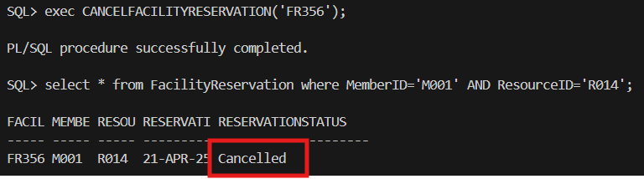
Sample Output:

4.4.5 Trigger 1: Auto-Close Facility on Reservation
Purpose :
This trigger automatically sets the status of a library resource to 'Closed' immediately after a new reservation is inserted into the FacilityReservation table, ensuring the resource is not double-booked.

Trigger code :
CREATE OR REPLACE TRIGGER trg_CloseFacilityReservation
AFTER INSERT ON FacilityReservation
FOR EACH ROW
BEGIN
UPDATE LibraryResource
SET LIBRARYRESOURCESTATUS = 'Closed'
WHERE ResourceID = :NEW.ResourceID;
END;

4.4.6 Trigger 2: Block Facility Reservations by Ineligible Members
Purpose :
This trigger prevents members with a status of 'Expired' or 'Blacklisted' from making facility reservations. It runs before any insert on the FacilityReservation table and raises an error if the member is not eligible.

Trigger code :
CREATE OR REPLACE TRIGGER trg_PreventReservationInvalid
BEFORE INSERT ON FacilityReservation
FOR EACH ROW
DECLARE
v_status VARCHAR2(20);
BEGIN
SELECT Status INTO v_status FROM Member WHERE MemberID = :NEW.MemberID;

IF v_status IN ('Expired', 'Blacklisted') THEN
RAISE_APPLICATION_ERROR(-20011, 'Member is not allowed to reserve facilities due to status: ' || v_status);
END IF;
END;

4.4.7 Report 1 : Book Reservations Status (Fulfilled and Unfulfilled)
Purpose :
This report's purpose is to display the status of book reservations where the status is 'Placed'. It checks each reservation to determine whether the book is available (fulfilled) or not (unfulfilled), then outputs a message indicating the result for each reservation.

Report code :
CREATE OR REPLACE PROCEDURE Report_UnfulfilledReservations AS
CURSOR reserve_cur IS
SELECT BookID, MemberID, ReservationDate, Status
FROM BookReservation
WHERE Status = 'Placed';

CURSOR book_avail_cur(p_BookID Book.BookID%TYPE) IS
SELECT Status
FROM Book
WHERE BookID = p_BookID;

BEGIN
DBMS_OUTPUT.PUT_LINE('📚 Book Reservations Status Report (Fulfilled and Unfulfilled)');
DBMS_OUTPUT.PUT_LINE('=====================================================');

FOR r IN reserve_cur LOOP
FOR b IN book_avail_cur(r.BookID) LOOP
IF b.Status = 'Available' THEN
DBMS_OUTPUT.PUT_LINE('✅ Book ID: ' || r.BookID || ' reserved by Member ID: ' || r.MemberID || ' on: ' || TO_CHAR(r.ReservationDate, 'YYYY-MM-DD') || ' - Reservation Fulfilled.');
ELSE
DBMS_OUTPUT.PUT_LINE('❌ Reservation not fulfilled for Book ID: ' || r.BookID || ' reserved by Member ID: ' || r.MemberID || ', Status: ' || b.Status);
END IF;
END LOOP;
END LOOP;

DBMS_OUTPUT.PUT_LINE('=====================================================');
DBMS_OUTPUT.PUT_LINE('================== END OF REPORT ===================');
END;
/

BEGIN
Report_UnfulfilledReservations;
END;
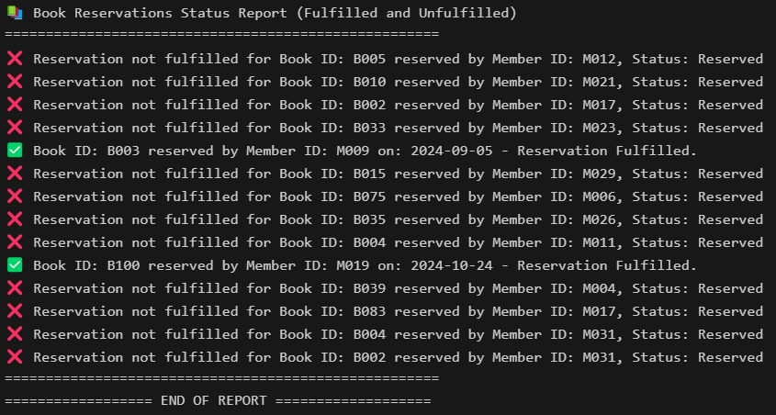
Sample Output :

4.4.8 Report 2 : Summary Report of Active Members by Type
Purpose :
This report's purpose is to generate a summary of all active members grouped by their membership type. It counts the number of active members for each type and displays the totals in a structured report format.

Report code :
CREATE OR REPLACE PROCEDURE Report_ActiveMembersByType IS
CURSOR member_summary IS
SELECT MemberType, COUNT(*) AS Total
FROM Member
WHERE Status = 'Active'
GROUP BY MemberType;
BEGIN
-- Header
DBMS_OUTPUT.PUT_LINE('📋 Active Members by Type Report');
DBMS_OUTPUT.PUT_LINE('========================================');

-- Body
FOR rec IN member_summary LOOP
DBMS_OUTPUT.PUT_LINE('👤 Member Type: ' || rec.MemberType);
DBMS_OUTPUT.PUT_LINE(' 🔢 Count : ' || rec.Total);
DBMS_OUTPUT.PUT_LINE('----------------------------------------');
END LOOP;

-- Footer
DBMS_OUTPUT.PUT_LINE('✅ Report Completed Successfully!');
END;
/

BEGIN
Report_ActiveMembersByType;
END;

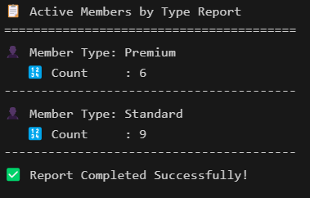
Sample Output :

4.5 WONG PENG SEUNG

4.5.1 Query 1 : Payment Details
Purpose :
This query purpose is to generate a report of payment details within a specified date range and payment status (Paid/Unpaid). It lists invoice ID, billing category, payment date, payment method, and billing amount, and calculates the total billing amount for the filtered records.
SQL statement :
SET LINESIZE 150
SET VERIFY OFF
SET PAGESIZE 50

-- Prompt inputs
ACCEPT Start_Date DATE FORMAT 'YYYY-MM-DD' PROMPT 'Enter Start Date (YYYY-MM-DD): '
ACCEPT End_Date DATE FORMAT 'YYYY-MM-DD' PROMPT 'Enter End Date (YYYY-MM-DD): '
ACCEPT Pay_Status CHAR PROMPT 'Enter Payment Status [Paid/Unpaid]: '

-- Column formatting
COL "Invoice ID" FORMAT A21 HEADING 'Invoice ID'
COL "Billing Category" FORMAT A20 HEADING 'Billing Category'
COL "Payment Date" FORMAT A15 HEADING 'Payment Date'
COL "Payment Method" FORMAT A20 HEADING 'Payment Method'
COL "Billing Amount" FORMAT 99999.99 HEADING 'Billing Amount'

-- Report title
TTITLE CENTER 'Payment Details between &Start_Date and &End_Date' RIGHT 'Page: ' FORMAT 999 SQL.PNO SKIP 2

-- Grouping and totals
BREAK ON REPORT
COMPUTE SUM LABEL 'Total Billing Amount:' OF "Billing Amount" ON REPORT

-- Main query
SELECT i.InvoiceID AS "Invoice ID",
b.Type AS "Billing Category",
TO_CHAR(i.PaymentDate, 'YYYY-MM-DD') AS "Payment Date",
i.PaymentMethod AS "Payment Method",
b.Amount AS "Billing Amount"
FROM Invoice i
JOIN Billing b ON i.BillingID = b.BillingID
WHERE b.PayStatus = '&Pay_Status'
AND i.PaymentDate BETWEEN TO_DATE('&Start_Date', 'YYYY-MM-DD') AND TO_DATE('&End_Date', 'YYYY-MM-DD')
ORDER BY i.PaymentDate;

-- Cleanup
CLEAR COLUMNS
TTITLE OFF

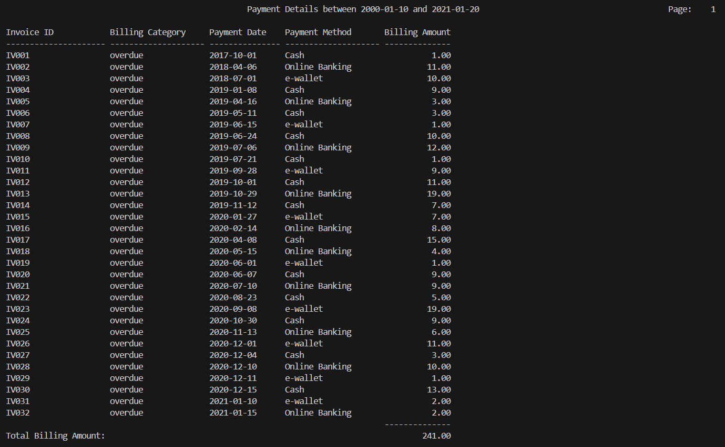
Sample Output :

4.5.2 Query 2 : Yearly Billing Report
Purpose :
This query purpose is to generate a yearly billing report that summarizes total billed, paid, and unpaid amounts for each month of a specified year. It groups data by month and formats zero values as "-", providing clear monthly and yearly financial totals.

SQL statement :
SET LINESIZE 150
SET VERIFY OFF
SET PAGESIZE 50

-- Prompt input for year
ACCEPT Year CHAR PROMPT 'Enter Year (e.g., 2022): '

-- Column formatting
COL "Month" FORMAT A20 HEADING 'Month'
COL "Total Billed" FORMAT A10 HEADING 'Total Billed'
COL "Total Paid" FORMAT A10 HEADING 'Total Paid'
COL "Total Unpaid" FORMAT A12 HEADING 'Total Unpaid'

-- Report title
TTITLE CENTER 'Yearly Billing Report for &Year' RIGHT 'Page: ' FORMAT 999 SQL.PNO SKIP 2

-- Grouping and totals
BREAK ON "Month"
COMPUTE SUM LABEL 'Total for Year:' OF "Total Billed" ON REPORT
COMPUTE SUM LABEL 'Total Paid for Year:' OF "Total Paid" ON REPORT
COMPUTE SUM LABEL 'Total Unpaid for Year:' OF "Total Unpaid" ON REPORT

-- Main query with TO_CHAR to format with "-" for zero values
SELECT TO_CHAR(b.DueDate, 'YYYY-MM') AS "Month",
CASE
WHEN SUM(b.Amount) = 0 THEN '-'
ELSE TO_CHAR(SUM(b.Amount), '99999.00')
END AS "Total Billed",
CASE
WHEN SUM(CASE WHEN i.PaymentDate IS NOT NULL THEN b.Amount ELSE 0 END) = 0 THEN '-'
ELSE TO_CHAR(SUM(CASE WHEN i.PaymentDate IS NOT NULL THEN b.Amount ELSE 0 END), '99999.00')
END AS "Total Paid",
CASE
WHEN SUM(CASE WHEN i.PaymentDate IS NULL THEN b.Amount ELSE 0 END) = 0 THEN ' -'
ELSE TO_CHAR(SUM(CASE WHEN i.PaymentDate IS NULL THEN b.Amount ELSE 0 END), '99999.00')
END AS "Total Unpaid"
FROM Billing b
LEFT JOIN Invoice i ON b.BillingID = i.BillingID
WHERE b.DueDate BETWEEN TO_DATE('&Year-01-01', 'YYYY-MM-DD') AND TO_DATE('&Year-12-31', 'YYYY-MM-DD')
GROUP BY TO_CHAR(b.DueDate, 'YYYY-MM')
ORDER BY TO_CHAR(b.DueDate, 'YYYY-MM');

-- Cleanup
CLEAR COLUMNS
TTITLE OFF

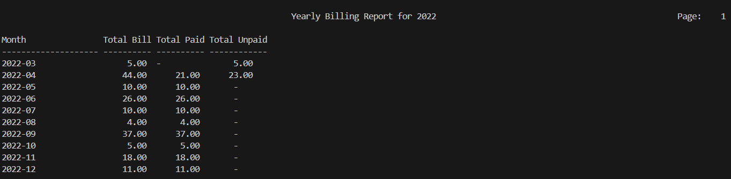
Sample Output :

4.5.3 Procedure 1 : Member Registration and Billing Setup
Purpose :
This procedure registers a new library member by inserting their details into the Member table and calculating the registration fee based on membership type (Standard or Premium). It then generates a billing ID and records the fee as an unpaid transaction in the Billing table.

Procedure code :
CREATE OR REPLACE PROCEDURE RegisterMember (
p_MemberID VARCHAR2,
p_Name VARCHAR2,
p_MemberIC VARCHAR2,
p_MemberType VARCHAR2,
p_PhoneNumber VARCHAR2,
p_Address VARCHAR2
) AS
v_RegisterFee NUMBER;
v_BillingID VARCHAR2(10);
BEGIN
-- Determine the registration fee based on membership type
IF p_MemberType = 'Standard' THEN
v_RegisterFee := 10;
ELSIF p_MemberType = 'Premium' THEN
v_RegisterFee := 20;
END IF;

-- Insert the new member record
INSERT INTO Member VALUES (
p_MemberID, p_Name, p_MemberIC, p_MemberType, p_PhoneNumber, p_Address,
SYSDATE, ADD_MONTHS(SYSDATE, 12), 'Active', NULL
);

-- Generate Billing ID using sequence
SELECT 'BL' || TO_CHAR(BillingSeq.NEXTVAL, 'FM000') INTO v_BillingID FROM dual;

-- Insert billing information
INSERT INTO Billing VALUES (
v_BillingID, p_MemberID, 'RegisterMember', v_RegisterFee, SYSDATE, 'Unpaid'
);
END;

exec REGISTERMEMBER('M031','Lim wei kang','040429-01-0399','Premium','0108016885','PV9 RESIDENSI');

Sample Output :

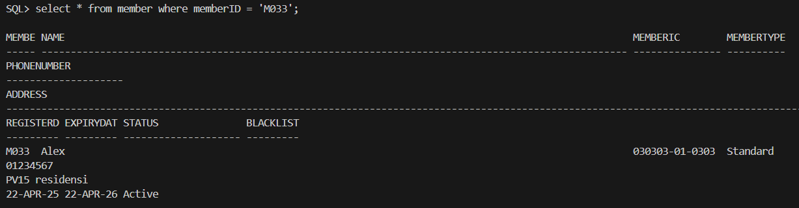

4.5.4 Procedure 2 : Technician-Based Maintenance Request Creation
Purpose :
This procedure creates a maintenance request by verifying that the technician's specialty matches the library resource type. If valid, it inserts the request, sets the resource status to 'Under Maintenance', and outputs a confirmation. If not, it raises an error indicating the technician is not qualified.

Procedure code :
CREATE OR REPLACE PROCEDURE CreateMaintenanceRequest (
p_TechnicianID VARCHAR2,
p_LibraryResourceID VARCHAR2,
p_LibrarianID VARCHAR2,
p_RequestDate DATE
) AS
v_TechnicianSpecialty VARCHAR2(50);
v_ResourceType VARCHAR2(50);
v_RequestID VARCHAR2(10);
BEGIN
-- Get Technician's specialty
SELECT Specialty INTO v_TechnicianSpecialty
FROM Technician
WHERE TechnicianID = p_TechnicianID;

-- Get Library Resource's type
SELECT ResourceType INTO v_ResourceType
FROM LibraryResource
WHERE ResourceID = p_LibraryResourceID;

-- Generate RequestID using sequence
v_RequestID := 'MR' || LPAD(seq_MaintenanceRequestID.NEXTVAL, 3, '0');

-- Check if specialty matches resource type (using LIKE for flexibility)
IF v_TechnicianSpecialty LIKE '%' || v_ResourceType || '%' THEN
-- Insert maintenance request
INSERT INTO MaintenanceRequest (
RequestID, TechnicianID, ResourceID, LibrarianID, RequestDate, Status
) VALUES (
v_RequestID, p_TechnicianID, p_LibraryResourceID, p_LibrarianID, p_RequestDate, 'Pending'
);

-- Update library resource status
UPDATE LibraryResource
SET LibraryResourceStatus = 'Under Maintenance'
WHERE ResourceID = p_LibraryResourceID;

DBMS_OUTPUT.PUT_LINE('Maintenance request created with ID: ' || v_RequestID);
ELSE
-- Raise error if mismatch
RAISE_APPLICATION_ERROR(-20001, 'Technician is not qualified for this resource type.');
END IF;
END;

exec CREATEMAINTENANCEREQUEST('T004','R003','L003',TO_DATE('2025-03-03','YYYY-MM-DD'));

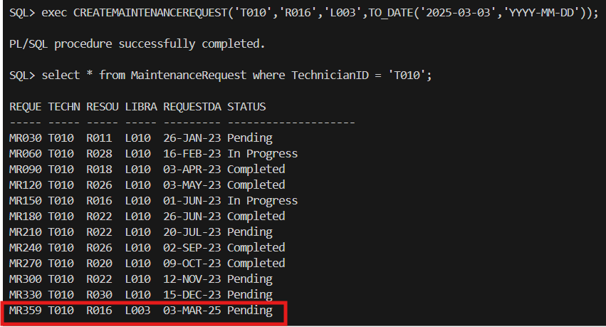
Sample Output :

4.5.5 Trigger 1 : Block Borrowing by Inactive Members
Purpose :
This trigger prevents members with a status of 'Expired' or 'Blacklisted' from making facility reservations. It runs before any insert on the FacilityReservation table and raises an error if the member is not eligible.

Trigger code :
CREATE OR REPLACE TRIGGER trg_PreventInactiveBorrow
BEFORE INSERT ON BorrowingRecord
FOR EACH ROW
DECLARE
v_status VARCHAR2(10);
BEGIN
SELECT Status INTO v_status FROM Member WHERE MemberID = :NEW.MemberID;
IF v_status != 'Active' THEN
RAISE_APPLICATION_ERROR(-20005, 'Inactive members cannot borrow books.');
END IF;
END;

4.5.6 Trigger 2 : Restrict Re-Reservation Within 14 Days
Purpose :
This trigger prevents members from reserving the same book more than once within a 14-day period. It checks for existing active reservations and raises an error before inserting a new record into the BookReservation table if a recent reservation already exists.

Trigger code :
CREATE OR REPLACE TRIGGER trg_PreventDuplicateReserve
BEFORE INSERT ON BookReservation
FOR EACH ROW
DECLARE
v_count NUMBER;
BEGIN
SELECT COUNT(*) INTO v_count
FROM BookReservation
WHERE MemberID = :NEW.MemberID
AND BookID = :NEW.BookID
AND Status IN ('Placed', 'Ready','Fulfilled')
AND ReservationDate >= SYSDATE - 14; -- only active reservations within 14 days

IF v_count > 0 THEN
RAISE_APPLICATION_ERROR(-20007, 'You have already reserved this book within the past 14 days.');
END IF;
END;

4.5.7 Report 1 : Active Member Borrowed Books
Purpose :
This report's purpose is to list all books currently borrowed by active members. It shows detailed borrowing information (book title, borrow date, and status) for each active member and summarizes the total number of books borrowed per member. If no books are found, it outputs a corresponding message.

Report code :
CREATE OR REPLACE PROCEDURE Report_ActMem_BorrowedBooks AS
CURSOR member_cur IS
SELECT MemberID, Name FROM Member WHERE Status = 'Active';

CURSOR books_cur(p_MemberID Member.MemberID%TYPE) IS
SELECT br.BookID, bt.Title, br.BorrowDate, br.Status
FROM BorrowingRecord br
JOIN BookTitle bt ON br.BookID = bt.BookID
WHERE br.MemberID = p_MemberID;

BEGIN
DBMS_OUTPUT.PUT_LINE('📚================ ACTIVE MEMBER BORROWED BOOKS REPORT ================');

FOR m IN member_cur LOOP
DBMS_OUTPUT.PUT_LINE(CHR(10) || '👤 Member: ' || m.Name || ' (ID: ' || m.MemberID || ')');
DBMS_OUTPUT.PUT_LINE('------------------------------------------------------------');

DECLARE
has_books BOOLEAN := FALSE;
total_books NUMBER := 0;
BEGIN
FOR b IN books_cur(m.MemberID) LOOP
DBMS_OUTPUT.PUT_LINE(' 📖 "' || b.Title ||
'" | Borrowed: ' || TO_CHAR(b.BorrowDate, 'DD-Mon-YYYY') ||
' | Status: ' || b.Status);
has_books := TRUE;
total_books := total_books + 1;
END LOOP;

IF NOT has_books THEN
DBMS_OUTPUT.PUT_LINE(' ❌ No borrowed books found.');
ELSE
DBMS_OUTPUT.PUT_LINE(' 📊 Total Borrowed Books: ' || total_books);
END IF;
END;
END LOOP;

DBMS_OUTPUT.PUT_LINE(CHR(10) || '✅============================ END OF REPORT ============================');
END;
/

BEGIN
Report_ActMem_BorrowedBooks;
END;

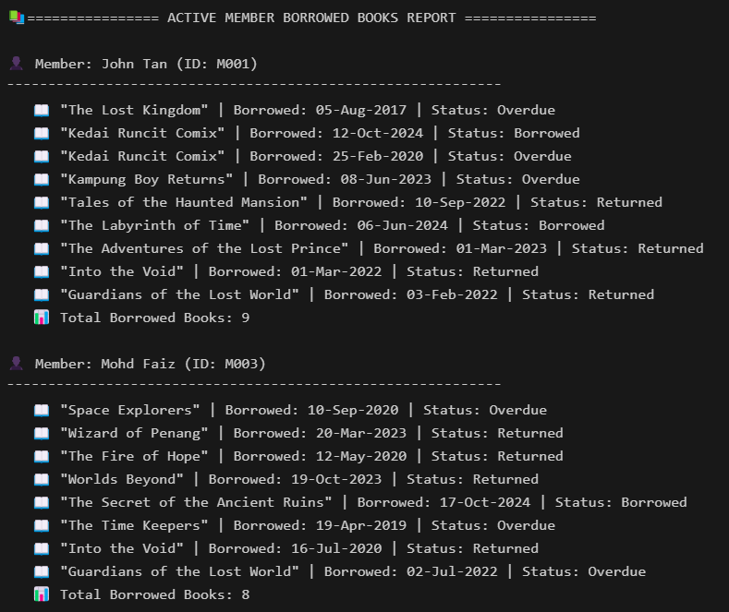
Sample Output :

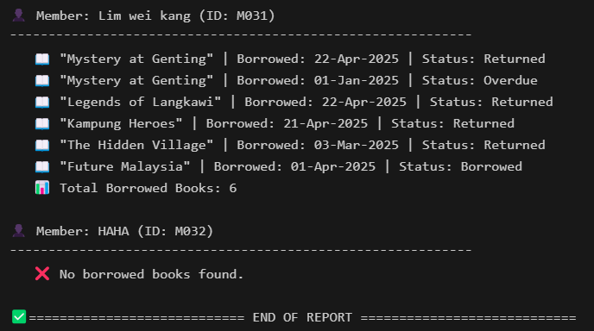

4.5.8 Report 2: Billing Details by Member ID with Title, Footer, and Total Amount
Purpose :
This report's purpose is to display detailed billing and invoice records for a specific member. It shows each billing entry along with its amount, type, status, and related invoice information. At the end, it calculates and displays the total amount due for the member.

Report code :
CREATE OR REPLACE PROCEDURE Report_Billing_ByMember(
p_MemberID IN Member.MemberID%TYPE
) AS
v_MemberName Member.Name%TYPE;
v_TotalAmount NUMBER := 0;

CURSOR bill_cur IS
SELECT BillingID, Type, Amount, PayStatus
FROM Billing
WHERE MemberID = p_MemberID;

CURSOR invoice_cur(p_BillingID Billing.BillingID%TYPE) IS
SELECT InvoiceID, PaymentDate, PaymentMethod
FROM Invoice
WHERE BillingID = p_BillingID;

BEGIN
-- Fetch the member's name for the title
SELECT Name
INTO v_MemberName
FROM Member
WHERE MemberID = p_MemberID;

-- Print header
DBMS_OUTPUT.PUT_LINE('📄 Billing Report for Member: '
|| p_MemberID || ' – ' || v_MemberName);
DBMS_OUTPUT.PUT_LINE('=================================================');

-- Loop through billing records
FOR b IN bill_cur LOOP
DBMS_OUTPUT.PUT_LINE('💳 Billing ID : ' || b.BillingID);
DBMS_OUTPUT.PUT_LINE(' Type : ' || b.Type);
DBMS_OUTPUT.PUT_LINE(' Amount : RM ' || TO_CHAR(b.Amount, 'FM999,999,990.00'));
DBMS_OUTPUT.PUT_LINE(' Status : ' || b.PayStatus);

-- Add the amount to the total
v_TotalAmount := v_TotalAmount + b.Amount;

-- Nested cursor for invoices
FOR i IN invoice_cur(b.BillingID) LOOP
DBMS_OUTPUT.PUT_LINE(' └─ Invoice ID : ' || i.InvoiceID);
DBMS_OUTPUT.PUT_LINE(' Date : ' || TO_CHAR(i.PaymentDate, 'YYYY-MM-DD'));
DBMS_OUTPUT.PUT_LINE(' Method : ' || i.PaymentMethod);
END LOOP;
DBMS_OUTPUT.PUT_LINE('-------------------------------------------------');
END LOOP;

-- Print the total amount at the end
DBMS_OUTPUT.PUT_LINE('=================================================');
DBMS_OUTPUT.PUT_LINE('Total Amount Due: RM ' || TO_CHAR(v_TotalAmount, 'FM999,999,990.00'));

-- Footer
DBMS_OUTPUT.PUT_LINE(CHR(10) || '========================= END OF REPORT =========================');
END;
/

BEGIN
Report_Billing_ByMember('M001');
END;

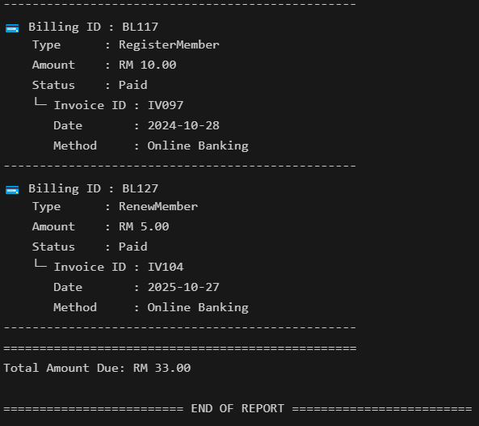
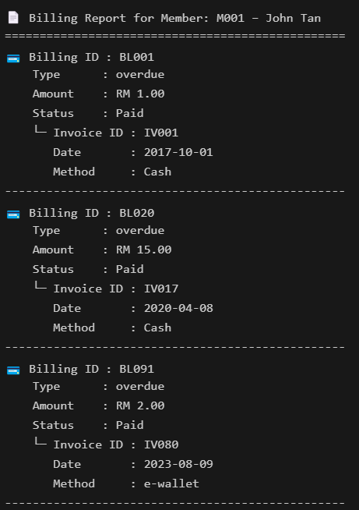
Sample Output :

Chapter 5 Extra Effort Highlights

5.1 (LEE XUE YI)

5.1.1 Sequence
Description :
The seq_invoice_id sequence is created to generate unique, incremented invoice IDs for the billing system. It starts at 105, and each subsequent value increments by 1. The sequence does not cache values to optimize for performance but generates them on demand, ensuring that no sequence values are wasted. Additionally, the sequence will not cycle; once it reaches its maximum value, it will raise an error instead of starting from the beginning. This guarantees that each invoice ID remains unique and sequential for tracking and organizational purposes.

Application in Work :
In my project, the seq_invoice_id sequence is used to generate unique and sequential invoice IDs for billing records. This is crucial for the integrity and traceability of billing transactions. Every time a new invoice is generated—whether for overdue payments or new charges—the system uses this sequence to assign a unique ID to the invoice, which is then stored in the Invoice table. The sequential IDs ensure no duplication and help in organizing billing records chronologically.
The sequence is particularly important in ensuring that every invoice generated has a unique identifier, which is vital for tracking payments, resolving discrepancies, and generating reports.
Sequence code :

CREATE SEQUENCE seq_invoice_id
START WITH 105
INCREMENT BY 1
NOCACHE
NOCYCLE;

5.1.2 Exception 1
Description :
The RAISE_APPLICATION_ERROR procedure is used to define a custom exception in Oracle SQL. In this case, it raises an error when an attempt is made to extend a loan that has already been extended once. The error code -20008 is used to identify this specific issue, and the message 'Loan has already been extended once.' is displayed to notify the user that they cannot perform the action.
The custom error number -20008 is within the range of user-defined exceptions (-20000 to -20999), which allows the developer to define meaningful error codes. This exception handling helps ensure business rules are followed, such as limiting the number of loan extensions.
Application in Work :
In my project, the RAISE_APPLICATION_ERROR is used in a trigger or procedure that enforces the rule that a loan can only be extended once. If a member attempts to extend a loan after it has already been extended, the procedure raises the exception, preventing the system from allowing further extensions. The exception is then caught by the system, which alerts the user with the custom error message 'Loan has already been extended once.'.
By using this exception, I ensure that the business logic is adhered to, preventing system misuse or data inconsistencies. This exception helps maintain control over loan extension actions, ensuring that the application behaves correctly and users are aware of any constraints on their actions.
Exception code :

RAISE_APPLICATION_ERROR(-20008, 'Loan has already been extended once.');

5.1.3 Exception 2
Description :
The RAISE_APPLICATION_ERROR procedure is used to raise a custom exception in Oracle SQL. In this case, it is used to prevent a member from borrowing books if their account status does not allow it (e.g., 'Expired', 'Blacklisted'). When the member tries to borrow a book, the exception checks their status. If the member's status is one of the restricted statuses (such as 'Expired' or 'Blacklisted'), the exception is raised, and the error message 'Member is not allowed to borrow books due to status: ' || v_status is displayed. The v_status variable dynamically includes the actual status of the member, providing a clear and personalized error message.

The error code -20010 is a unique, user-defined error number that falls within the -20000 to -20999 range, which is reserved for custom exceptions in Oracle.

Application in Work :
In my project, the RAISE_APPLICATION_ERROR is used within a procedure or trigger that checks the member's status before allowing them to borrow books. If the member’s status is either 'Expired' or 'Blacklisted', this exception is raised, preventing the borrowing action from occurring.
For example, when a library staff member tries to issue a book to a member whose status is not allowed for borrowing, the system will raise this error. The error message, which includes the member's current status, will be displayed to the staff, informing them why the borrowing action cannot proceed.
This exception ensures that only members with valid statuses can borrow books, thereby maintaining the integrity of the borrowing system and enforcing library policies. It helps prevent members with overdue accounts or violations from accessing library resources, ensuring the system remains fair and consistent.
Exception code :

RAISE_APPLICATION_ERROR(-20010, 'Member is not allowed to borrow books due to status: ' || v_status);

5.1.4 Output Formatting for Query 1
Description:
The column formatting commands in the query are used to customize the appearance of the output, ensuring that each column is properly aligned and easy to read. For example, the "Record ID" column is formatted to a maximum of 15 characters with the header 'Record ID'. This ensures that the column has enough space to display the data without truncation. Similarly, the "Member ID" column is formatted to 20 characters, allowing for a consistent presentation of member identifiers, with the header clearly labeled 'Member ID'.
The "Book ID" column is formatted with a width of 15 characters, as this is typically sufficient for book identifiers. The "Borrow Date" and "Due Date" columns are formatted with a width of 11 and 10 characters, respectively, as these columns will hold date values, which generally fit within those lengths, ensuring the dates are clearly visible. Their headers are labeled appropriately as 'Borrow Date' and 'Due Date' to reflect the content in each column.
The "Return Date" column is formatted similarly to the "Due Date" column, as it also stores date values. Finally, the "Librarian Name" column is given a width of 25 characters to accommodate longer names, and its header is labeled 'Librarian Name', ensuring that the name of the librarian associated with each borrowing record is properly displayed.
Application in Work :
These column formatting commands are typically used when generating formatted reports or querying data that requires specific column widths in Oracle SQL. For example, if you're generating a report for borrowed books, member details, and librarian involvement, these commands will ensure the output is neatly formatted, making it easier for users to read and understand the results.
For instance, when querying for records of book borrowings, this formatting will ensure that all columns (Record ID, Member ID, Book ID, etc.) have a consistent and readable structure in your output, improving the presentation and clarity of the data.
Formatting code :
COL "Record ID" FORMAT A15 HEADING 'Record ID'
COL "Member ID" FORMAT A20 HEADING 'Member ID'
COL "Book ID" FORMAT A15 HEADING 'Book ID'
COL "Borrow Date" FORMAT A11 HEADING 'Borrow Date'
COL "Due Date" FORMAT A10 HEADING 'Due Date'
COL "Return Date" FORMAT A10 HEADING 'Return Date'
COL "Librarian Name" FORMAT A25 HEADING 'Librarian Name'

5.1.5 Output Formatting for Query 2
Description :
The "Book Title" column is formatted to a maximum width of 50 characters using FORMAT A50. This ensures that book titles, which may vary in length, are fully visible without truncation. The header is labeled 'Book Title' to clearly indicate that this column contains the titles of the books.
The "Category" column is given a width of 20 characters (FORMAT A20), which is ideal for displaying book categories such as "Fiction," "Science," or "Fantasy." The column is titled 'Category' to make it clear that the data within this column represents the genre or type of the book.
The "Total Reserved" column is formatted as a numeric field with a width of 4 digits (FORMAT 9999). This ensures that the total number of reservations for each book is displayed clearly and accurately. The column header 'Total Reserved' is used to indicate that this column shows the number of reservations made for the corresponding book.
Application in Work :
The "Book Title" column formatting is essential for displaying the full name of the book in the report, especially when dealing with long titles that may otherwise be cut off. By setting the column width to 50 characters, the system ensures that the book titles are fully visible, providing a more user-friendly and accessible report for library staff or members reviewing borrowing and reservation records.
The "Category" column is used to display the genre or classification of each book. With a width of 20 characters, this column provides enough space for various category names, such as "Non-fiction" or "Historical Fiction," ensuring that the data is readable and does not overlap. This is crucial for organizing books by category, making it easier to manage reservations or search for specific genres.
The "Total Reserved" column is used to track the number of reservations each book has. By formatting it as a numeric field, the system ensures that the reservation count is displayed cleanly and aligned, making it easier for library staff to monitor the popularity of books and manage inventory. The header helps users quickly identify this information, which is essential for tracking demand and determining which books may need to be restocked or prioritized.

Formatting code :
COL "Book Title" FORMAT A50 HEADING 'Book Title'
COL "Category" FORMAT A20 HEADING 'Category'
COL "Total Reserved" FORMAT 9999 HEADING 'Total Reserved'

5.1.6 Indexes 1
Description :
The idx_bookTitle_category index is created on the Category column of the BookTitle table. This index is designed to improve the performance of queries that filter or join based on the Category column. By indexing this column, the database can more efficiently retrieve records that match a specific book category, reducing the time it takes to search through large datasets.

Application in Work :
This index is particularly useful for queries that filter books by their category. For example, when generating reports or searching for books in a specific category, the index allows the database to quickly access the relevant records without performing a full table scan. Additionally, this index can speed up joins between the BookTitle table and other tables that use Category as a filter or join key, improving overall system performance and query response time.

Indexes code:
CREATE INDEX idx_bookTitle_category
ON BookTitle (Category);

5.1.7 Indexes 2
Description :
The idx_bookReservation index is created on the MemberID, BookID, and Status columns of the BookReservation table. This composite index is designed to improve query performance by allowing the database to quickly locate records based on these commonly queried fields. The reason for creating this index is that MemberID, BookID, and Status are frequently used in filtering and joining operations. By indexing these columns, the system reduces the need for full table scans, thereby improving the overall efficiency of the queries.

Application in Work :
This index is particularly useful for queries that filter or join the BookReservation table based on MemberID, BookID, or Status, such as retrieving a member's reservation history or checking the status of a specific book. The purpose of the index is to speed up data retrieval by enabling the database to quickly access relevant rows, improving the performance of the system when handling large datasets. As a result, queries will execute faster, leading to better system responsiveness and reduced load times.

Indexes code:
CREATE INDEX idx_bookReservation
ON BookReservation (MemberID, BookID, Status);

5.2 (LIM YEE SYUEN)

5.2.1 Sequence
Description :
The seq_BookReserveID sequence is created to generate unique and sequential IDs for book reservations. The sequence starts at 343, meaning the first reservation record will have the ID '343'. Each subsequent ID increments by 1. The sequence is configured with the NOCACHE option, meaning that no values are pre-allocated to improve performance, and values are generated only when needed. This ensures that the reservation IDs are created on-demand without any pre-generated gaps. The sequence helps in ensuring that each book reservation has a unique identifier for tracking and managing reservations efficiently.

Application in Work :
The seq_BookReserveID sequence is used whenever a new book reservation is made. When a member reserves a book, the system uses this sequence to generate a unique BookReserveID for that reservation record. This ID ensures that each reservation can be uniquely identified and tracked in the system, preventing conflicts and ensuring the proper management of book reservations.
The sequence is critical for maintaining organized reservation records, as it guarantees that each reservation is assigned a distinct, sequential identifier, which is essential for future references, tracking, and reporting of reservations.
Sequence code :

CREATE SEQUENCE seq_BookReserveID
START WITH 343
INCREMENT BY 1
NOCACHE;

5.2.2 Exception 1
Description :
The RAISE_APPLICATION_ERROR procedure is used to raise a custom exception when a member tries to exceed the limit of 3 active reservations in the system. The error number -20001 is used to uniquely identify this exception. The message 'You cannot have more than 3 active reservations.' is generated when a member attempts to make a new reservation while already having 3 active (or placed) reservations.
The -20001 error code falls within the user-defined error range (-20000 to -20999), allowing the system to handle this particular situation by notifying the user of the policy violation. This helps enforce the library's reservation limits for fairness and resource management.
Application in Work :
In my project, this exception is used within a reservation process to enforce a rule that limits each member to a maximum of 3 active reservations. When a member tries to make a fourth reservation, the system checks the number of existing active reservations (those with statuses such as 'Placed' or 'Ready'). If the member already has 3 active reservations, the system raises this custom exception and prevents the new reservation from being made.
For instance, when a member attempts to reserve a book while having 3 ongoing reservations, the exception is triggered, and the message 'You cannot have more than 3 active reservations.' is displayed. This provides clear feedback to the member or system user, helping to ensure the reservation system is used efficiently and fairly, and preventing overbooking of library resources.
By using this exception, the system maintains control over member reservation activity, ensuring that the library’s resources are appropriately managed and that no member can reserve an excessive number of books at one time.
Exception code :

RAISE_APPLICATION_ERROR(-20001, 'You cannot have more than 3 active reservations.');

5.2.3 Exceptions 2
Description :
The RAISE_APPLICATION_ERROR procedure is used to raise a custom exception when a member's status is not eligible for performing certain actions, such as borrowing books or reserving facilities. In this case, the exception is raised if a member's status is either 'Expired' or 'Blacklisted'. The error number -20002 is used to uniquely identify this exception, and the message 'Member is either expired or blacklisted.' is displayed to inform the user about the issue with the member's status.
The error code -20002 is within the user-defined exception range (-20000 to -20999), ensuring that the exception can be properly identified and handled.
Application in Work :
In my project, this exception is used to prevent members with expired or blacklisted statuses from borrowing books, making reservations, or performing any actions that require active membership. When a member tries to perform such an action (e.g., borrow a book or reserve a facility), the system checks their status. If the status is either 'Expired' or 'Blacklisted', the exception is triggered.
For example, when a library staff member tries to issue a book to a member whose account has expired or is blacklisted, this exception will be raised. The system will display the error message 'Member is either expired or blacklisted.', which helps staff understand why the transaction cannot proceed.
This exception ensures that the library's policies regarding expired or blacklisted members are enforced, preventing members who do not meet the criteria from accessing library services. It helps maintain system integrity by ensuring that only valid members can use the resources.
Exception code :

RAISE_APPLICATION_ERROR(-20002, 'Member is either expired or blacklisted.');

5.2.4 Output Formatting for Query 1
Description :
The "Request ID" column is formatted with a width of 12 characters (FORMAT A12), which is suitable for displaying the unique identifier of each maintenance request. The header for this column is labeled 'Request|ID' to clearly indicate that this column represents the ID of each request.
The "Technician Name" column is formatted with a width of 20 characters (FORMAT A20), allowing enough space to display the technician's name fully. The header 'Technician|Name' helps to identify this column as containing the names of the technicians assigned to the maintenance requests.
The "Resource ID" column is formatted with a width of 12 characters (FORMAT A12) to display the unique identifier of the resource involved in the maintenance request. The column header 'Resource|ID' identifies this as the column that holds the resource IDs.
The "Resource Name" column is formatted with a width of 30 characters (FORMAT A30), which provides ample space for the name of the resource, ensuring that even long names can be fully displayed. The header 'Resource|Name' clearly labels the column as containing the names of the resources.
The "Request Date" column is formatted with a width of 20 characters (FORMAT A20), which is appropriate for displaying dates in a readable format. The column header 'Request|Date' is used to indicate that this column represents the date on which the maintenance request was made.
The "Status" column is formatted with a width of 15 characters (FORMAT A15), providing enough space to display the status of the maintenance request (e.g., 'In Progress,' 'Completed'). The header 'Status' clearly indicates that this column will contain the status of each request.
Application in Work :
The "Request ID" column formatting ensures that each maintenance request has a properly aligned and readable identifier. This is critical in tracking the status of individual requests, as the ID helps differentiate between each request. The column width of 12 characters ensures the ID is visible without truncation, making it easy for users to reference.
The "Technician Name" column allows the full name of the technician to be displayed clearly, ensuring that users can easily identify which technician is assigned to each request. The column width of 20 characters is suitable for most technician names, ensuring readability and consistency in the report.
The "Resource ID" column ensures that the unique identifier for each resource involved in the maintenance request is displayed in a fixed-width format, maintaining consistency and clarity across the report. This is important for referencing specific resources when reviewing or analyzing maintenance requests.
The "Resource Name" column ensures that the names of the resources (e.g., machines, facilities) involved in the maintenance request are fully visible. With a width of 30 characters, this column provides enough space to display long resource names without cutting off important details.
The "Request Date" column formatting ensures that the date of each maintenance request is displayed in a consistent, readable format. This is important for tracking the timeline of maintenance activities and understanding when requests were made.
The "Status" column helps track the current state of each request, whether it's 'In Progress,' 'Completed,' or another status. The column width of 15 characters ensures that the status is displayed clearly and fully, preventing truncation of the text.
Formatting code :
COLUMN "Request ID" FORMAT A12 HEADING 'Request|ID'
COLUMN "Technician Name" FORMAT A20 HEADING 'Technician|Name'
COLUMN "Resource ID" FORMAT A12 HEADING 'Resource|ID'
COLUMN "Resource Name" FORMAT A30 HEADING 'Resource|Name'
COLUMN "Request Date" FORMAT A20 HEADING 'Request|Date'
COLUMN "Status" FORMAT A15 HEADING 'Status'

5.2.5 Output Formatting for Query 2
Description :
The "Book Category" column is formatted with a width of 20 characters (FORMAT A20) to accommodate a variety of book genres such as "Fiction," "Science," or "Mystery." The column header is labeled 'Book Category', clearly indicating that this column contains the genre or classification of the book.
The "Member ID" column is also formatted with a width of 20 characters (FORMAT A20) to display the unique identifier assigned to each library member. The header 'Member ID' ensures that users understand the content of this column refers to the member’s identity in the system.
The "Member Name" column uses a width of 30 characters (FORMAT A30), allowing enough space for full names, including those with middle names or longer surnames. The header 'Member Name' identifies this column as displaying the name of the member who borrowed the book.
The "Book ID" column is formatted with a width of 10 characters (FORMAT A10), which is suitable for displaying short, unique book identifiers. The header 'Book ID' ensures that the user understands this column refers to the ID of the borrowed book.
The "Borrow Date" column is formatted with a width of 18 characters (FORMAT A18) to display date and time information in a clear and readable format. The header 'Borrow Date' indicates that this column shows the date the book was borrowed by the member.
Application in Work :
In my work, the "Book Category" column helps organize borrowing records by genre, making it easier to analyze trends in book preferences. The 20-character width ensures that even longer category names are fully displayed, providing clarity for staff and users when reviewing the data.
The "Member ID" column is essential for uniquely identifying who borrowed which book. Its formatting allows for consistent alignment in reports, which helps staff quickly locate member records when managing borrowing activities or generating summaries.
The "Member Name" column supports identification in a more human-readable format. By allocating 30 characters, the report ensures that full names are shown without truncation, which is helpful when matching IDs to real people, especially in customer service or audit situations.
The "Book ID" column provides a quick reference to the specific book being borrowed. Since book IDs are usually alphanumeric codes or short strings, a 10-character format is appropriate for displaying this information cleanly and consistently in the report.
Lastly, the "Borrow Date" column tracks the date when the book was issued. This is vital for monitoring loan periods, enforcing return policies, and identifying overdue books. The 18-character width accommodates full date formats, ensuring that time and date information is not cut off or misaligned in the output.
Formatting code :
COL "Book Category" FORMAT A20 HEADING 'Book Category'
COL "Member ID" FORMAT A20 HEADING 'Member ID'
COL "Member Name" FORMAT A30 HEADING 'Member Name'
COL "Book ID" FORMAT A10 HEADING 'Book ID'
COL "Borrow Date" FORMAT A18 HEADING 'Borrow Date'

5.2.6 Indexes 1
Description :
The idx_maintenanceRequest index is a composite index created on the TechnicianID, ResourceID, and Status columns of the MaintenanceRequest table. This index is designed to improve the performance of queries that filter or join on these three columns. By creating an index on these frequently queried fields, the database can efficiently locate records matching specific criteria, reducing the time it takes to search through large volumes of data.

Application in Work :
The idx_maintenanceRequest index speeds up queries that filter or join on TechnicianID, ResourceID, and Status in the MaintenanceRequest table. It enhances performance when retrieving records based on specific technicians, resources, or statuses, and improves join efficiency between the MaintenanceRequest, Technician, and LibraryResource tables. This results in faster data retrieval and better overall system performance, especially for large datasets.

Indexes code:
CREATE INDEX idx_maintenanceRequest
ON MaintenanceRequest (TechnicianID, ResourceID, Status);

5.2.7 Indexes 2
Description :
The idx_technician_specialty index is created on the TechnicianID and Specialty columns of the Technician table. This composite index improves query performance by allowing the database to efficiently search for technicians based on both their TechnicianID and Specialty, which are commonly used together in filtering and joining operations.

Application in Work :
This index enhances performance when querying the Technician table for specific technicians and their associated specialties. It is particularly useful for queries that filter technicians by their specialty or when joining with other tables that reference these columns. The index reduces the need for full table scans, improving the speed of data retrieval and making the system more efficient, especially when dealing with large numbers of technicians.

Indexes code:
CREATE INDEX idx_technician_specialty
ON Technician (TechnicianID, Specialty);

5.3 (LIM WEI KANG)

5.3.1 Sequence 1
Description :
The BillingSeq sequence is designed to automatically generate unique billing identifiers for each billing transaction within the Library Management System. It starts at 131 and increments by 1 for each new value, ensuring a continuous and non-repetitive numbering system. This sequence is primarily used during the member registration process and when recording payments such as registration fees, membership renewals, and fines. By leveraging this sequence, the system avoids manual input errors and maintains consistency and traceability in billing records. It supports streamlined invoice generation and enhances overall system integrity in financial operations.

Application in Work :
In my project, the seq_invoice_id sequence is used to generate unique and sequential invoice IDs for billing records. This is crucial for the integrity and traceability of billing transactions. Every time a new invoice is generated—whether for overdue payments or new charges—the system uses this sequence to assign a unique ID to the invoice, which is then stored in the Invoice table. The sequential IDs ensure no duplication and help in organizing billing records chronologically.The sequence is particularly important in ensuring that every invoice generated has a unique identifier, which is vital for tracking payments, resolving discrepancies, and generating reports.
Sequence code :

CREATE SEQUENCE BillingSeq
START WITH 131
INCREMENT BY 1
NOCACHE;

5.3.2 Sequence 2
Description :
The seq_BorrowingRecordID sequence is used to auto-generate unique identifiers for each new borrowing transaction in the library system. It starts with the number 301 and increases by 1 for every new value generated. The sequence includes the NOCACHE and NOCYCLE options to ensure that numbers are generated in order, with no preallocation or repetition after reaching the limit.

Application in Work :
This sequence is applied when a member borrows a book from the library. During the borrowing process, the system calls seq_BorrowingRecordID.NEXTVAL to generate a new unique ID for that transaction. This ID is then used as the primary key for inserting a new row into the BorrowingRecord table, which contains information such as the Member ID, Book ID, Borrow Date, Due Date, and Status. This process ensures accurate tracking of all borrow activities, supports policies like borrowing limits, loan extensions, and overdue penalties, and maintains referential integrity across related database tables.
Sequence code :

CREATE SEQUENCE seq_BorrowingRecordID
START WITH 301
INCREMENT BY 1
NOCACHE
NOCYCLE;

5.3.3 Exceptions 1
Description :
This exception is triggered when a user attempts to fulfill a reservation for a book that has not yet been confirmed as "Available" in the system. In library systems where books are reserved and issued based on availability and proper sequence, this exception plays a crucial role in maintaining logical integrity. It ensures that fulfillment of a reservation—changing its status to “Fulfilled”—only occurs when the book has already been returned or set to “Available.” This avoids situations where books that are still on loan, lost, or otherwise unavailable are mistakenly marked as fulfilled. The system cross-verifies the current status of the book using the Book table and throws this exception if the availability condition is not met. The custom error message included in the exception helps the user or administrator understand that the fulfillment action is invalid due to the book’s status not aligning with reservation protocols.

Application in Work :
This exception is typically used within database triggers or PL/SQL procedures that govern the reservation and fulfillment lifecycle. For instance, when a library staff member attempts to update a reservation's status to “Fulfilled,” the system first checks the book’s status in the database. If the book has not yet been returned and is not marked as “Available,” this exception is raised to block the transaction. It prevents bypassing the reservation queue and guards against premature status changes that could result in inventory mismanagement or conflicts between borrowers. The use of this validation ensures that book circulation data is accurate, and only valid fulfillment actions proceed. It supports better control over book lending and enhances the user experience by enforcing rules consistently across operations.

Exception code :

RAISE_APPLICATION_ERROR(-20001, 'Book is not reserved.');

5.3.4 Exceptions 2
Description :
This exception is raised when an operation attempts to update a book reservation’s status to “Fulfilled” while the current reservation status is not “Ready.” In a structured library system, reservations must follow a defined lifecycle: starting as “Placed,” transitioning to “Ready” once the book becomes available, and only then proceeding to “Fulfilled” when the member collects the book. This exception enforces that structured flow and prevents status transitions from occurring out of sequence. It ensures that a book cannot be marked as collected if it has not yet been marked as ready for collection. This check prevents logical errors, preserves reservation integrity, and avoids inconsistencies in the reservation tracking mechanism.

Application in Work :
This exception is generally applied in database procedures or triggers that oversee status transitions in the reservation process. For instance, when a librarian or system operator tries to mark a reservation as “Fulfilled,” the system first verifies that the reservation is in the “Ready” state. If the reservation is still in the “Placed” state—meaning the book has not yet been returned or is not available for pickup—the system will reject the update and raise this exception. This validation step is critical to maintaining the reservation lifecycle in the correct order: Placed → Ready → Fulfilled. Without it, members could potentially fulfill reservations before the system is ready, leading to book inventory errors or conflicting claims on the same book. This exception ensures orderly book handovers and consistent user experience.

Exception code :

RAISE_APPLICATION_ERROR(-20005, 'Reservation is not marked as Ready.');

5.3.5 Output Formatting for Query 1
Description :
This script segment is used to format the display output of specific columns in SQL*Plus or similar Oracle-based environments. The COL command defines how each column will be displayed when SELECT statements are executed, helping to align and present output in a clean and readable tabular format. Each column is assigned a specific format width using FORMAT Axx, where Axx sets the character width (e.g., A15 for 15 characters). Additionally, the HEADING clause is used to customize the column headers, ensuring that the labels shown in the report output are meaningful and user-friendly. This formatting is particularly useful when generating reports from the database that involve string or date data, allowing users to interpret the results with ease.

Application in Work :
This column formatting script is typically applied in SQL scripts that generate structured outputs—such as borrowing history reports or administrative dashboards—using Oracle SQL*Plus. For example, when displaying a member's borrowing history, columns such as "Member ID," "Borrow Date," or "Return Date" can appear misaligned or truncated if not formatted properly. This code ensures that each column has enough space for data to be fully visible and neatly aligned, improving the clarity of the output. By applying standardized formatting, database administrators and users can quickly review data in a visually consistent layout, enhancing productivity and accuracy during audits, monitoring, or data reviews. It is especially useful in command-line environments where GUIs are not used.

Formatting code :
-- Column formatting
COL "Member ID" FORMAT A15 HEADING 'Member ID'
COL "Member Name" FORMAT A30 HEADING 'Member Name'
COL "Borrow Date" FORMAT A15 HEADING 'Borrow Date'
COL "Due Date" FORMAT A15 HEADING 'Due Date'
COL "Return Date" FORMAT A15 HEADING 'Return Date'
COL "Status" FORMAT A20 HEADING 'Status'

5.3.6 Output Formatting for Query 2
Description :
This column formatting script is used to customize the display output of resource reservation data in an Oracle SQL*Plus environment. The COL command assigns specific formatting widths to each column—such as "Resource Name", "Member ID", "Member Name", and "Reservation Date"—using the FORMAT Axx directive, where Axx specifies the width in characters. The HEADING clause labels each column header with a user-friendly name that appears in the final output. This type of formatting is critical for maintaining data clarity and consistent alignment when viewing results, especially when dealing with long names or varied date formats in text-based reporting tools.

Application in Work :
This formatting configuration is typically used when generating reports related to facility or resource reservations in a library or academic environment. For instance, administrators may need to review which members have reserved particular resources (like discussion rooms or study equipment) on specific dates. The formatted output helps ensure that fields such as "Resource Name" and "Reservation Date" are displayed clearly, avoiding truncated values and misalignment that can occur in default SQL outputs. By enforcing structured column widths and headings, this script enhances the usability of printed or exported reports, making them more presentable and easier to interpret for library staff, auditors, or decision-makers. It also helps ensure consistency in layout across different report scripts in the system.

Formatting code :
-- Column formatting
COL "Resource Name" FORMAT A30 HEADING 'Resource Name'
COL "Member ID" FORMAT A10 HEADING 'Member ID'
COL "Member Name" FORMAT A30 HEADING 'Member Name'
COL "Reservation Date" FORMAT A20 HEADING 'Reservation Date'

5.3.7 Indexes 1
Description :
The index idx_borrowingRecord is created on the BorrowingRecord table using the columns MemberID, BookID, and Status. This composite index is designed to enhance the performance of queries that frequently access these columns in filtering, joining, or ordering operations. Since MemberID and BookID are commonly used to identify a borrowing transaction and Status helps track the state of that borrowing (e.g., Borrowed, Returned, Overdue), indexing them significantly speeds up query execution times. By maintaining a sorted order of these fields, Oracle can retrieve the relevant data more efficiently without performing full table scans.

Application in Work :
This index plays a crucial role in optimizing the execution of the report query. The query retrieves borrowing records for members, filtering data based on MemberID, and orders results using br.BorrowDate. Additionally, Status is included in the report output, and although not directly filtered in this specific query, it is often used in similar transactional queries or filters. The presence of the index allows Oracle to quickly locate records associated with specific members and books, improving retrieval times especially in large datasets. In a library system where borrowing activities are frequent and historical records are extensive, this index ensures that reports on book borrowings, member activity, or overdue status are generated swiftly and with minimal resource consumption. It also supports the integrity of interactive systems, like search or audit trails, by delivering faster access to borrowing data.

Indexes code:
CREATE INDEX idx_borrowingRecord
ON BorrowingRecord (MemberID, BookID, Status);

5.3.8 Indexes 2
Description :
The index idx_member_ID_type_status is created on the Member table and includes three columns: MemberID, MemberType, and Status. This composite index is designed to optimize queries that filter or join based on these three attributes. In relational databases, such an index improves performance by allowing the database engine to quickly locate rows that match the specified conditions, rather than scanning the entire table.

Application in Work :
In the SQL report, the Member table is joined with the FacilityReservation and LibraryResource tables using the MemberID field, and the report relies on retrieving member details such as Name and potentially evaluating the Status or MemberType for filtering or display. By having an index that includes MemberID, MemberType, and Status, the query benefits from faster access paths, particularly during joins and when filters or grouping are applied based on these fields. This index helps the system efficiently locate active members who used a specific resource within a defined date range, enhancing the overall performance of the report generation process.

Indexes code:
CREATE INDEX idx_member_ID_type_status
ON Member (MemberID, MemberType, Status);

5.4 (NGOI WAN XUAN)

5.4.1 Sequence
Description :
The seq_reservation_id sequence is designed to generate unique and sequential reservation IDs starting from 351, incrementing by 1 with each new entry. It includes the NOCACHE and NOCYCLE options to ensure consistent ID generation without skipping or repeating values, thereby maintaining the integrity and traceability of reservation records in the system.

Application in Work :
This sequence is used when a member makes a new book or facility reservation. During the reservation process, the system calls seq_reservation_id. NEXTVAL to assign a new, unique reservation ID. This ID is inserted into the FacilityReservation or BookReservation table, along with details such as Member ID, Resource ID, Reservation Date, and Reservation Status. This ensures that every reservation is uniquely identified and tracked, supporting logic for auto-cancellation, overdue checking, and status updates such as "PLACED", "READY", or "FULFILLED".
Sequence code :

CREATE SEQUENCE seq_reservation_id
START WITH 351
INCREMENT BY 1
NOCACHE
NOCYCLE;

5.4.2 Exceptions 1
Description :
This exception is triggered when a member attempts to make a facility reservation but their membership status does not permit such actions. The system performs a validation check against the member’s current status in the Member table. If the status is anything other than 'Active'—such as 'Expired', 'Blacklisted', or any other disallowed condition—the system blocks the reservation attempt and raises this exception. It helps ensure that only qualified, active members can access exclusive services, such as room bookings or special equipment. The error message is dynamic and informative; it explicitly includes the specific status (v_status) of the member that led to the reservation rejection. This feedback not only guides the user on why the action was denied but also reinforces the system’s adherence to policy rules regarding member eligibility.

Application in Work :
This exception is widely implemented within PL/SQL stored procedures or database triggers that manage facility reservations. For example, in a procedure like InsertFacilityReservation, before executing an insert into the FacilityReservation table, the system first queries the member’s current status. If the retrieved status is not 'Active', the system immediately halts the operation and raises this application error. This validation is particularly critical in maintaining the exclusivity and fairness of facility access. By enforcing membership rules programmatically, the system ensures that shared resources—like meeting rooms, VIP zones, or multimedia equipment—are reserved only by members in good standing. This improves system reliability, minimizes manual checks by staff, and enhances user trust in automated control. In a real-world context, this is especially useful in large libraries or community centers where managing access through status-based eligibility reduces conflicts and misuse of reservation privileges.

Exception code :

RAISE_APPLICATION_ERROR(-20011, 'Member is not allowed to reserve facilities due to status: ' || v_status);

5.4.3 Exceptions 2
Description :
This exception is raised when a system operation attempts to cancel a facility reservation that has already been processed and marked as “Cancelled” in the database. The purpose of this exception is to prevent redundant cancellation attempts and avoid unnecessary updates that could lead to data inconsistencies or operational confusion. It functions as a protective validation step that checks the current reservation status before executing any changes. When triggered, this exception provides immediate feedback to the user or process attempting the cancellation, ensuring that the system maintains accurate reservation records. This is especially useful in multi-user environments where concurrent operations might occur or when users are unaware of the current status of their past requests.

Application in Work :
This exception is most commonly implemented in stored procedures such as CancelFacilityReservation, where it is essential to verify the current reservation status before performing the cancellation. Upon receiving a cancellation request, the system retrieves the status of the reservation record from the FacilityReservation table. If the status is already 'Cancelled', the exception is immediately thrown to halt the process and notify the user or system administrator that the reservation does not require further action. This behavior prevents duplicate operations and ensures that cancellation logs remain clean and accurate. Moreover, it improves the user experience by providing clear messages about the state of their request, while also maintaining system efficiency by avoiding redundant writes to the database. In production environments, this helps prevent bugs related to race conditions or improper client retries.

Exception code :

RAISE_APPLICATION_ERROR(-20001, 'Reservation is already cancelled.');

5.4.4 Output Formatting for Query 1
Description :
Column formatting in SQL*Plus is used to control the appearance of output when displaying query results. In this context, the formatting commands ensure that text and numerical data are presented in a consistent, organized, and readable format. For example, "Book Title" and "Author" columns are assigned widths of 30 and 20 characters respectively (FORMAT A30 and FORMAT A20), making space for longer titles and names. Similarly, for statistical data, columns like "Category", "Avg Borrow Days", and "Total Borrowed" use FORMAT A15 or FORMAT 9999, aligning numeric results for clarity. Each column is also assigned a clear heading using the HEADING clause to enhance the readability of the report output.

Application in Work :
This formatting is particularly useful in generating structured reports for both book listings and borrowing statistics. In book search results, formatting ensures that longer titles and author names are not cut off and remain properly aligned, making it easier for users and librarians to scan through records efficiently. In summary or analytical reports, such as those showing average borrowing durations or the total number of borrows per category, formatted numeric columns ensure that figures are properly aligned and easy to compare. Overall, column formatting supports better data presentation, facilitates decision-making, and contributes to a more professional and user-friendly report layout within the library management system.

Formatting code :
-- Column formatting
COL "Book Title" FORMAT A30 HEADING 'Book Title'
COL "Author" FORMAT A20 HEADING 'Author'
COL "Category" FORMAT A15 HEADING 'Category'
COL "Avg Borrow Days" FORMAT 9999 HEADING 'Avg Borrow Days'
COL "Total Borrowed" FORMAT 9999 HEADING 'Total Borrowed'

5.4.5 Output Formatting for Query 2
Description :
This set of column formatting instructions is designed to enhance the presentation of a resource reservation ranking report. Each column is tailored to a specific width and heading label for optimal readability. The "Rank" column is formatted with FORMAT 99 to ensure alignment of numeric rankings. The "Resource ID" uses A12, providing adequate space for IDs while maintaining compactness. The "Resource Name" and "Location" columns use A30 and A25 respectively, allowing longer descriptive names to fit without wrapping or truncation. Lastly, "Reservation Count" uses FORMAT 999 to align numeric counts clearly, especially in ranking-based comparisons.

Application in Work :
This formatting is typically applied in SQL*Plus when generating reports that rank library resources based on the number of reservations they receive. For example, in an administrative report showing the most frequently reserved facilities (such as study rooms or equipment), the "Rank" helps prioritize items. The "Resource ID" and "Resource Name" identify the item, while "Location" provides contextual information. The "Reservation Count" reveals usage frequency. By aligning data neatly and using meaningful column widths, the formatting improves report legibility and aids library staff in analyzing reservation trends and making informed decisions about resource allocation or expansion.

Formatting code :
-- Column formatting
COL "Rank" FORMAT 99 HEADING 'Rank'
COL "Resource ID" FORMAT A12 HEADING 'Resource|ID'
COL "Resource Name" FORMAT A30 HEADING 'Resource|Name'
COL "Location" FORMAT A25 HEADING 'Location'
COL "Reservation Count" FORMAT 999 HEADING 'Reservation|Count'

5.4.6 Indexes 1
Description :
The index idx_book_bookID_status is created on the Book table and includes the columns BookID and Status. This index is designed to enhance the performance of queries that frequently filter or join on these two columns. By indexing both BookID and Status, the database can more quickly locate the rows that meet specific conditions involving these fields, which is particularly useful in scenarios involving filtering available books or grouping and counting borrow records by book status.

Application in Work :
In the query, the index is particularly beneficial in the clause WHERE b.Status = 'Available', which is used to filter only books that are currently available for borrowing. Since the query also involves a join with the BorrowingRecord table using BookID, having an index that includes both BookID and Status significantly speeds up the lookup and filtering processes. The database can use the index to swiftly narrow down the relevant records from the Book table, reducing the number of full-table scans and improving overall query efficiency. This becomes crucial in reporting queries like this, which involve date range filtering, aggregation (SUM(b.BorrowedCount)), and result limiting (ROWNUM <= 5) for generating a top 5 most borrowed books report. Without such an index, the performance would degrade as the volume of book and borrowing data increases.

Indexes code:
CREATE INDEX idx_book_bookID_status
ON Book (BookID, Status);

5.4.7 Indexes 2
Description :
The index idx_libraryResource is created on the LibraryResource table, specifically on the columns ResourceID and LibraryResourceStatus. This index is designed to optimize query performance when filtering or joining based on these columns. Since ResourceID is the primary linkage between LibraryResource and FacilityReservation, and LibraryResourceStatus is frequently checked to determine the availability or operational state of a resource, this composite index improves both lookup and filtering operations.

Application in Work :
In the query, data is retrieved by joining LibraryResource with FacilityReservation using the ResourceID field. Additionally, the query filters results where LibraryResource.ResourceType = 'facility' and applies grouping and counting logic to rank facilities by reservation frequency. Although LibraryResourceStatus is not directly used in this query, having it in the index still benefits any other operations or future query extensions that might require status filtering. The index enhances the execution plan by allowing the database engine to quickly locate matching ResourceID entries in LibraryResource, significantly reducing the time needed for joins and filtering. This is particularly useful when working with large datasets in systems that track usage and availability of multiple library facilities.

Indexes code:
CREATE INDEX idx_libraryResource
ON LibraryResource (ResourceID, LibraryResourceStatus);

5.5 (WONG PENG SEUNG)

5.5.1 Sequence
Description :
The seq_MaintenanceRequestID sequence is responsible for generating unique identifiers for maintenance requests, starting at 351 and increasing by 1 with each new request. The NOCACHE option ensures that the sequence values are generated one at a time without preallocation, reducing the risk of skipped values in case of system failure.

Application in Work :
This sequence is applied whenever a new maintenance request is logged in the system—typically when a librarian reports a damaged or malfunctioning resource (e.g., a broken facility or equipment). When the CreateMaintenanceRequest procedure is executed, the system uses seq_MaintenanceRequestID.NEXTVAL to produce a distinct RequestID, which is then stored in the MaintenanceRequest table along with the technician ID, librarian ID, resource ID, request date, and status. This facilitates efficient tracking, management, and follow-up of all maintenance activities within the library system.
Sequence code :

CREATE SEQUENCE seq_MaintenanceRequestID
START WITH 351
INCREMENT BY 1
NOCACHE;

5.5.2 Exceptions 1
Description :
This exception is raised when a member with an inactive status attempts to borrow a book from the library system. The system enforces strict membership validation rules that only allow members with an active status to perform borrowing activities. Memberships can become inactive due to expiration, blacklisting (from unpaid fines or overdue books), or other disciplinary actions. By raising this exception, the system ensures that borrowing privileges are granted only to members who meet the eligibility criteria. The message clearly informs the user of their ineligibility and the reason for rejection, helping to guide corrective action, such as renewing membership or paying fines.

Application in Work :
This exception is typically implemented in the borrowing process, specifically within a procedure or trigger that validates the member’s status before creating a new borrowing record. When a member tries to borrow a book—whether through a self-service kiosk, staff terminal, or online system—the system first checks the status associated with the member’s ID. If the status is not 'Active', the system will immediately raise this exception to block the transaction. This application prevents system misuse by enforcing business rules that protect library resources from being accessed by members who are no longer in good standing. It also helps staff efficiently identify issues with a member’s account and guide them on necessary actions like membership renewal or fine settlement. This control contributes to maintaining fair access, data integrity, and operational discipline across the borrowing system.

Exception code :

RAISE_APPLICATION_ERROR(-20005, 'Inactive members cannot borrow books.');

5.5.3 Exceptions 2
Description :
This exception is raised when a member attempts to reserve the same book again within 14 days of their previous reservation. The system is designed to prevent duplicate or repeated reservations for the same book in a short time frame, which ensures fair access for other users. This 14-day restriction helps manage resource availability efficiently and discourages monopolization of high-demand titles. The error message explicitly informs the member of the restriction and reinforces the reservation policy.

Application in Work :
This exception is typically used in a BEFORE INSERT trigger on the BookReservation table. When a new reservation is being created, the trigger checks for any existing reservations by the same member for the same book within the past 14 days. If such a reservation is found, the system halts the operation and raises this exception. This ensures that members do not repeatedly block a book’s availability by continuously placing back-to-back reservations. In practice, this rule is especially useful in busy libraries where certain books are in high demand. It promotes fairness, allows broader access to resources, and reduces unnecessary system load from redundant reservation entries. Staff and members benefit from this safeguard as it keeps reservation records clean and avoids confusion over reservation eligibility.

Exception code :

RAISE_APPLICATION_ERROR(-20007, 'You have already reserved this book within the past 14 days.');

5.5.4 Output Formatting for Query 1
Description :
This column formatting setup is crafted to present invoice and billing data in a clear and structured way within a SQL*Plus report. The "Invoice ID" is formatted with A21, which accommodates longer alphanumeric codes. "Billing Category" and "Payment Method" both use A20, ensuring enough space for descriptive values. "Payment Date" uses A15, which is suitable for displaying standard date formats. The "Billing Amount" column is numeric and formatted as 99999.99, which ensures that currency values (up to five digits before the decimal) are aligned properly and easy to read.

Application in Work :
This formatting is especially useful in generating financial or transaction reports from a library management system. For instance, when producing an invoice summary, this formatting ensures that each piece of billing data—such as the type of payment (Cash, Online, etc.), category (Registration, Renewal, Fine), and date—is neatly presented. The billing amount, a critical financial value, is formatted to always show two decimal places, ensuring clarity in monetary reporting. This format is commonly applied in procedures or scripts that display member billing histories, track payments, or generate finance-related summaries for auditing and reporting purposes.

Formatting code :

-- Column formatting
COL "Invoice ID" FORMAT A21 HEADING 'Invoice ID'
COL "Billing Category" FORMAT A20 HEADING 'Billing Category'
COL "Payment Date" FORMAT A15 HEADING 'Payment Date'
COL "Payment Method" FORMAT A20 HEADING 'Payment Method'
COL "Billing Amount" FORMAT 99999.99 HEADING 'Billing Amount'

5.5.5 Output Formatting for Query 2
Description :
This column formatting setup is designed to display monthly billing statistics in a report-friendly layout. The "Month" column is allocated a width of A20, making it suitable for full month names along with the year (e.g., "January 2025"). The financial figures—"Total Billed", "Total Paid", and "Total Unpaid"—are formatted using A10 or A12, ensuring that the monetary values are neatly aligned and clearly labeled. This helps distinguish between different types of billing transactions across reporting periods.

Application in Work :
This formatting is particularly useful in monthly financial overview reports in a library management system. It enables administrators or finance officers to quickly review how much was billed, how much has been paid, and how much remains unpaid for each month. The structure supports accountability and transparency in billing operations, allowing trends to be observed over time. For example, during auditing or management review, this format provides a snapshot of billing efficiency and member payment behavior, enabling better decision-making and forecasting.

Formatting code :

-- Column formatting
COL "Month" FORMAT A20 HEADING 'Month'
COL "Total Billed" FORMAT A10 HEADING 'Total Billed'
COL "Total Paid" FORMAT A10 HEADING 'Total Paid'
COL "Total Unpaid" FORMAT A12 HEADING 'Total Unpaid'

5.5.6 Indexes 1
Description :
The index idx_billing_ID_payStatus is created on the Billing table, specifically targeting the columns MemberID and PayStatus. This index is designed to enhance the performance of SQL operations that involve filtering or joining based on these columns. Indexes are database objects that speed up data retrieval at the cost of additional storage and maintenance during data manipulation (INSERT, UPDATE, DELETE). By indexing MemberID and PayStatus, the database engine can quickly locate and access rows with specific member IDs and their corresponding payment statuses—such as "Paid" or "Unpaid"—without having to scan the entire Billing table.

Application in Work :
This index proves highly useful in the execution of the billing report query where the payment status and member filtering are involved. In the provided SQL report, the Billing table is joined with the Invoice table, and the condition b.PayStatus = '&Pay_Status' is used to retrieve records that match a user-specified payment status. Additionally, the filtering is further narrowed down by payment dates between Start_Date and End_Date. With the index in place, the query optimizer can efficiently retrieve only those rows where the PayStatus matches the input, drastically reducing I/O operations. This results in faster generation of payment reports, especially when dealing with large volumes of billing records. The index not only enhances performance but also ensures that the system responds in a timely manner to end-users running financial summaries or audits.

Indexes code:
CREATE INDEX idx_billing_ID_payStatus
ON Billing (MemberID, PayStatus);

5.5.7 Indexes 2
Description :
The index idx_invoice_billingID is created on the BillingID column of the Invoice table. This index facilitates faster lookups and join operations where the Invoice table is accessed via the BillingID, which acts as a foreign key connecting to the Billing table. Since BillingID is commonly used in joins, particularly in reports involving financial summaries or invoice details, indexing this column greatly improves query performance.

Application in Work :
In the query, the Invoice table is joined with the Billing table using the BillingID field.This join is fundamental for retrieving invoice-related data like payment date and calculating amounts paid or unpaid. The idx_invoice_billingID index enhances the efficiency of this join by allowing the database engine to quickly locate matching BillingID values in the Invoice table without scanning the entire table. This is particularly valuable in reports that aggregate billing data monthly, as in this script, where performance can degrade with large datasets. By enabling fast access to relevant rows, the index supports timely and scalable generation of annual financial reports.

Indexes code:
CREATE INDEX idx_invoice_billingID
ON Invoice (BillingID);

